

May 2023

What can we learn about industries’ vulnerability to overseas price shocks from Merchandise trade data in BLADE?

Conference paper

Melisa Bubonya

Catherine de Fontenay

Tyler Reysenbach

Phillip Smith

James Thiris

The views expressed in this paper are those of the staff involved and do not necessarily reflect the views of the Productivity Commission.

|  |
| --- |
| The Productivity Commission acknowledges the Traditional Owners of  Country throughout Australia and their continuing connection to land,  waters and community. We pay our respects to their Cultures, Country and Elders past and present.  The Productivity Commission  The Productivity Commission is the Australian Government’s independent research and advisory body on a range of economic, social and environmental issues affecting the welfare of Australians. Its role, expressed most simply, is to help governments make better policies, in the long term interest of the Australian community.  The Commission’s independence is underpinned by an Act of Parliament. Its processes and outputs are open to public scrutiny and are driven by concern for the wellbeing of the community as a whole.  Further information on the Productivity Commission can be obtained from the Commission’s website (www.pc.gov.au).  © Commonwealth of Australia 2023  CC By logo  With the exception of the Commonwealth Coat of Arms and content supplied by third parties, this copyright work is licensed under a Creative Commons Attribution 4.0 International licence. In essence, you are free to copy, communicate and adapt the work, as long as you attribute the work to the Productivity Commission (but not in any way that suggests the Commission endorses you or your use) and abide by the other licence terms. The licence can be viewed at: https://creativecommons.org/licenses/by/4.0.  The terms under which the Coat of Arms can be used are detailed at: www.pmc.gov.au/government/commonwealth-coat-arms.  Wherever a third party holds copyright in this material the copyright remains with that party. Their permission may be required to use the material, please contact them directly.  An appropriate reference for this publication is: Bubonya, M, de Fontenay, C, Reysenbach, T, Smith, P and Thiris, J 2023, *What can we learn about industries’ vulnerability to overseas price shocks from Merchandise trade data in BLADE?,* Conference paper, Productivity Commission, Canberra  Publication enquiries:  Phone 03 9653 2244 | Email publications@pc.gov.au |

Introduction[1],[2]

Australia faces inflationary pressures from supply chain shocks abroad, inflation abroad that may not be fully reflected in exchange rates, and a period of loose domestic monetary policy. The combination makes it difficult to identify which products and services may be affected by inflation. It is particularly difficult to identify the impact of supply chain shocks, as they lead to large changes in relative prices: for example, the Ukraine war has caused price spikes in gas and petroleum, barley and wheat. Understanding the impact of these overseas price shocks require us to understand the exposure of different industries: which industries use those products, and how sensitive the industry is to a price shock.

A large literature beginning with Dornbusch (1987) explored how international shocks affect domestic prices. Much of this literature focused on understanding why Purchasing Power Parity does not seem to hold. As a result, some papers have compared the impact of the broad-based exchange rate shock on different industries, based on industry characteristics such as the degree of market power and the share of imported inputs (Amiti et al. 2014, Goldberg and Campa 2010, Burstein et al. 2005). Nakamura and Zerom (2010), Hellerstein (2008) and Goldberg and Verboven (2001) looked at the impact an exchange rate shock or a shock to the cost of a key input has on a specific industry. But all of these papers have examined the impact of an input price changes on the price of the final product. This paper takes a complementary approach, measuring the elasticity of demand for the input. If demand for an input is found to be elastic, the implication is that customers will not bear the full brunt of a price increase in the input, either because the firm can substitute away from the input, or because consumer demand for the final product is elastic.

Australia does not have a dataset that collects input and output data from its manufacturing firms, unlike some other countries. Such manufacturing-based datasets are increasingly less representative, however, as the service sector grows in importance worldwide. This paper introduces an alternative Australian dataset that provides insight into the use of inputs in different industries, and the likely impact of a cost shock on each of those industries.

The Merchandise imports and exports data collected by the Department of Foreign Affairs and Trade (DFAT) is integrated into the Business Longitudinal Analysis Data Environment (BLADE) dataset.[3] While the dataset has some limitations, it is an improvement on past datasets and allows us to identify the industries that use a particular type of input heavily. It can also allow us to estimate how elastic the demand is for that input.

The first section of this paper presents analysis of input use by industry from 2017–2018 Merchandise trade data in BLADE, updating the analysis in our *Vulnerable Supply Chains* report (2021). The second part of the paper estimates demand elasticity for selected products using Merchandise trade data that was made available to the Commission during the *Vulnerable Supply Chains* report. We provide some case studies of specific vulnerable imports, but the methodology is applicable to any import.

Vulnerable imports are the appropriate focus for an analysis of potential disruptions in supply as they are more likely than other imports to be impacted by events in specific countries. In the event of a shock, policymakers need to determine which industries are most exposed to risk because of their dependence on vulnerable products.

To analyse inflation, a larger set of imported goods are of interest, because non-vulnerable imports can still be subject to price shocks and can still impact prices in some economically significant industries. A price shock to a core input such as petroleum may impact several important industries, even though petroleum products are not vulnerable because they are sourced from numerous countries. And policymakers may still need to know which industries are most exposed to surging overseas inflation, particularly if prices are rising at different rates for different goods.

For either type of policy question – which industries are at risk due to supply chain disruptions and which industries are exposed to overseas inflation – the analysis proceeds in a similar fashion. The merchandise trade data can in principle be used to identify how much of a product is imported by each Australian firm, and other components of BLADE makes it possible to identify which industry each importing firm belongs to. Then the merchandise trade data can be used to identify the demand elasticity of a product in each industry, through observing how demand changes in response to price changes.

Our analysis confirms that chemicals and personal protective equipment are the most likely categories of vulnerable imports to cause serious disruptions to an essential industry. While some other imports are both vulnerable and economically significant, such as laptop computers, they are primarily capital goods and their disruption would not cause a short-term crisis. Moreover, our estimates of the total elasticity of demand for six selected chemicals suggests that for several of these, the elasticity is significantly different from zero, suggesting that the economy has the ability to substitute away from the use of those chemicals or from the use of the products or services that use those chemicals. Analysis at the industry level may reveal a greater dependency on selected chemicals.

BLADE data has limitations for both analyses, however. One of the most significant is that some firms do not import their products directly, but instead use intermediaries.

If BLADE has limitations for analysing price shocks and inflation shocks, should Australia respond by developing new data sources? Given the declining importance of manufacturing in many OECD countries, a Census of Manufacturing seems unlikely to deliver maximum benefits. On the contrary, it may be advantageous that Australia is not tied to a large-scale survey focused on manufacturing. It is worth identifying what type of survey of inputs and outputs might be best suited for a modern service-oriented economy. We conclude by briefly discussing this question.

1. Identifying which industries uses specific imports

We outline the methodology for identifying which industries use a specific import such as petroleum. We do so by using vulnerable imports as an example: we identify vulnerable imports used by essential industries. But the methodology would be the same for analysing any import of interest.

### Data

The Merchandise Imports and Clearances data collected by the Department of Foreign Affairs and Trade provides monthly observations of each product imported through Australia’s ports and airports. An observation includes the product’s 10-digit Harmonised Tariff Item Statistical Code (HTISC), the port of arrival, the weight and total price (both including and excluding customs insurance and freight) and the importing firm’s Australian Business Number (ABN).

The analysis in section 1 was undertaken using the Merchandise Imports and Clearances data for 2017–2018 in BLADE, and the analysis in section 2 uses unpublished Merchandise Imports and Clearances data from 2010 to 2019 obtained directly from the ABS. The latter dataset did not include the importing firm’s ABN.

### Vulnerable imports

In our report on *Vulnerable Supply Chains* (PC 2021), 2016–2017 Merchandise Imports and Clearances data was used to identify vulnerable imports.

Following the previous report (PC 2021) an import is defined as vulnerable if more than 80% of Australia’s imports are from a single country, ***and*** if global trade in the product is highly concentrated by country[4] (the Herfindahl-Hirschman index is more than 3,100 or a single exporting country has more than 50% market share), ***and*** if Australia imports from the nation that is the main global supplier.

The Commission concluded that the 8-digit HTISC level was on average the most accurate for identifying vulnerabilities. At the 10-digit level, there were too many categories that were close substitutes for each other; and a vulnerability identified in a 10-digit category might not be a real vulnerability.

In 2016–2017 there were 5,862 types of imported goods at the 8-digit HTISC, of which 1,327 were imported primarily from one country. The Commission identified 292 imports as vulnerable at the 8‑digit HTISC level (PC 2021).

### Vulnerable imports used in essential industries

The next section updates the 2021 report by analysing merchandise trade data from 2017-18, and utilises BLADE instead of identifying the Australian National Accounts Input-Output tables published by the ABS to determine which industries used vulnerable goods, as was done in 2021.

A **key data** **requirement** for the analysis of vulnerable imports in different industriesis the ability to link imports data with industry information.

The data sets required from BLADE are:

* BLADE core, which is built from administrative data on all active businesses. The ABS assigns each firm a 4‑digit Australia New Zealand Standard Industrial Classification (ANZSIC) code.
* Merchandise Imports and Clearances data. As described above, these categories are aggregated to the 8-digit level.

The main advantage of BLADE is that these two datasets are linked. The firm that imports a particular good can be identified. This allows for analysis at the firm level and industry level, including for firms of different sizes. Firms can also be analysed across years.

Classifying firms at the 4-digit ANZSIC level creates 506 different industries. From these industries, the Commission identified a subset we define as ‘essential industries.’ We identified 81 essential industries, outlined in Attachment A. This process necessarily involved some subjective judgement. As discussed in our report, the Commission was focused on ‘industries that are essential to life and limb’ such as water, electricity, basic communications, retail banking, and health. (An analysis that was focused on the economic costs of an external shock might instead focus on industries that are large employers, such as construction.) We were also able to include retailers of products that are essential to life and limb, for example pharmacies and fuel service stations.

BLADE can then be used to identify which firms import the 292 vulnerable products, and what industries those firms belong to. (Analysis of other import categories of interest, such as wheat or gas, would proceed similarly.)

Identifying the importer’s industry in BLADE has significant advantages relative to the approach in the *Vulnerable Supply Chains* (2021) report, which used the Australian National Accounts Input-Output tables published by the ABS to determine which industries used vulnerable goods.[5] The input-output tables break the Australian economy down into 114 industries and only 114 categories of goods (instead of 5862). Therefore, the input-output tables cannot conclusively identify which of the 114 industries use a specific eight-digit HTISC product. As a result, strong assumptions have to be imposed, such as assuming that the use of an eight-digit HTISC is proportional to the use of the broader industry’s products that it belongs to. Also, the essential industries included some sub-industries that are unlikely to be essential. For example, using 4‑digit ANZSIC codes one can select ‘Banking’ (6221) as an essential industry, because a collapse of retail banking would precipitate a crisis; but Financial Asset Investing (6240) can be excluded. In the Input-Output tables, in contrast, Finance is one industry that cannot be subdivided. Likewise, Retailing is one industry in the Input-Output tables, whereas with ANZSIC codes one can identify vital components such as pharmaceutical retailing (4271).

#### Results

Using BLADE, 223 of the 292 vulnerable products are identified as being imported by firms in essential industries. Figure 1 shows the number of vulnerable products used by essential industries when using BLADE (re-aggregating the 81 ANZSIC industries into eight essential industries).

**Figure 1 – Number of vulnerable imports used in essential industriesa**

Using BLADE, 2017–18

Number of HTISC products:
Wholesale 202
Logistics 116
Health 91
Government 49
Communications 44
Energy 23
Water Services 15
Banking 6

**a.** Wholesale industries is separated from logistics industries when using BLADE.

Source: ABS (*Business Longitudinal Analysis Data Environment, BLADE*, Cat. no. 8178.0, Microdata.

Comparing the nature of the goods identified in this updated analysis with those in the *Vulnerable Supply Chains* report, it would appear that BLADE is slightly better at identifying potentially critical goods used in essential industries. For example, in health the BLADE analysis identifies a larger array of chemicals including, iodine, ketone-phenols, etc. Reassuringly, the BLADE analysis also finds that a variety of food stuffs that were identified as vulnerable in the original work, such as catfish and mushrooms, are not actually used in essential industries.[6]

Table 1 presents the complete list of vulnerable imports for one industry, hospitals (ANZSIC 8401), as an example. More generally, across industries, an inspection of the list of goods identified by the BLADE analysis confirms that **chemicals** and **personal protective equipment** are the most obvious categories of goods that might be both vulnerable, used in essential industries, and critical to the functioning of those industries. In other words, these products may be used by essential industries such as hospitals, and a short-term disruption in their supply could be very serious. The first two products in table 1 correspond to personal protective equipment.

The analysis still identifies vulnerable products used by essential industries that are not actually important to the operation of those industries, such as statuettes and wrist watches. Common-sense or analysis of elasticities of demand (as outlined in the next section) is needed to eliminate a number of products that would be dispensable in the event of disruptions in supply or strong inflation.

**Table 1 – All vulnerable imports purchased directly by hospitals (excluding psychiatric hospitals) (ANZSIC 8401), 2017‑18**

| **HTISC code** | **HTISC description** |
| --- | --- |
| 39262029 | Garments, of plastics or of other materials of HS 3901 to HS 3914 (excluding corset busks; and anti-radiation suits, anti-contamination suits and similar protective garments; and goods of HS 9619) |
| 39262090 | Articles of apparel and clothing accessories (including gloves, mittens and mitts) of plastics or of other materials of HS 3901 to 3914 (excluding corset busks; garments; anti-radiation or anti-contamination suits & sim protective garments; and HS 9619) |
| 49090000 | Printed postcards, personal greeting cards, message and announcement cards, whether or not illustrated |
| 61159610 | Socks, ankle-socks, sockettes and the like knitted or crocheted, of synthetic fibres (excl. graduated compression hosiery) |
| 64029990 | Footwear, with outer soles and uppers of rubber or plastic (excluding covering the ankle, metal toe-caps, thongs, waterproof, for sport, diving etc) not exceeding size 1, 2nd series |
| 84713000 | Portable automatic data processing machines, weighing not more than 10 kg consisting of at least a central processing unit, a keyboard and a display |
| 85131000 | Portable electric lamps designed to function by their own source of energy (e.g. dry batteries, accumulators, magnetos) (excluding lighting equipment of 8512) |
| 85285200 | Monitors, not incorporating television reception apparatus, capable of directly connecting to and designed for use with an automatic data processing machine of heading 8471 (excluding cathode-ray tube monitors) |
| 96039000 | Brooms, brushes (exluding roller squeegees); hand operated; mops, feather dusters and squeegees; mech floor sweepers, not motorised; prepared knots and tufts for brooms or brushmaking |

Source: ABS (*Business Longitudinal Analysis Data Environment*, BLADE, Cat. no. 8178.0, Microdata).

Table 2 indicates all the vulnerable chemicals that are used by the human pharmaceutical and medicinal product manufacturing industry (ANZSIC 1841). This industry and these chemicals are obvious candidates for further exploration.

**Table 2 – Chemical imports by the human pharmaceutical and medicinal product manufacturing industry (ANZSIC 1841), 2017‑18**

| **HTISC code** | **HTISC description** |
| --- | --- |
| 28012000 | Iodine |
| 28362000 | Disodium carbonate |
| 29145000 | Ketone-phenols & ketones with other oxygen function |
| 29181400 | Citric acid |
| 29181600 | Gluconic acid, its salts & esters |
| 29214400 | Diphenylamine & its derivatives; salts thereof |
| 29223900 | Amino-aldehydes, amino-ketones, amino-quinones & salts thereof (excluding those containing more than one kind of oxygen function, amfepramone (INN), methadone (INN), normethadone (INN) and salts thereof) |
| 29336900 | Heterocyclic compounds with nitrogen hetero-atom(s) only, containing an unfused triazine ring, whether or not hydrogenated, in the structure (excl. melamine, cyanuric acid and its derivatives and atrazine) |
| 29381000 | Rutoside (rutin) and its derivatives |
| 29394200 | Pseudoephedrine (INN) and its salts |

Source: ABS (Business Longitudinal Analysis Data Environment, BLADE, Cat. no. 8178.0, Microdata).

Some of the vulnerable products identified seem important to production, but they are capital goods, or inputs to capital goods. This includes laptop computers; receivers; safety glass; monitors; and specialised lamps. Firms usually have more ability to substitute around capital goods than intermediate goods (PC 2021). Faced with a shortage of a capital good, a firm can use existing capital goods more intensively, or it can invest more in repairing existing capital goods. For example, mining companies have been known to resurrect old tyres from dumping groups during periods of shortages of tyres for large mining equipment. As a result, an interruption in supply of these products would be less likely to precipitate a crisis. As to whether a price spike in capital goods (or an input to capital goods) is likely to generate significant inflation, it would depend on whether the price spike is likely to be long-lasting or permanent. Firms have more ability to postpone purchases of capital goods than purchases of intermediate goods.

#### Limitations of BLADE

Despite these benefits, BLADE data also has weaknesses. The most important weakness is that many products are not imported directly by firms, but by wholesalers. As a result, given that BLADE identifies the importing firm, it is not always possible to identify the firm that will be ultimately using the import as an input into essential products or services.

The ‘wholesale’ category includes a broad range of firms. Wholesale is defined as firms that buy intermediary and finished products but do not own the means of production. It includes import merchants and wholesalers whose primary focus is domestic wholesale. It also includes a large range of companies that design, test and develop products in Australia and have them produced overseas.

Products imported by ‘the wholesale industry’ may be destined to any industry, or directly to the retail market. Thus excluding wholesalers would provide an incomplete picture of the dependence of an industry on any particular imports. For example, the list in table 1 is unlikely to include all vulnerable imports used in hospitals. Taking vulnerable imports in essential industries as an example shows that wholesalers play a significant role:

* Analysing all wholesale industries reveals that wholesalers import 48% of each vulnerable product on average, but this differs by product type.
* Of the 292 vulnerable products, 223 of them are imported by firms in essential industries, and 202 are imported by wholesalers (figure 1). Thus, imports through wholesalers feature in almost every vulnerable product category.

More research is needed on the role of wholesalers on the Australian end of the supply chain. It may be that some industries commonly import all of their inputs directly, whereas other industries use intermediaries. Exploring the patterns in the data while using information obtained directly from an industry about its input usage would be valuable.

Furthermore, if a product is commonly imported by one industry and resold to other industries, the merchandise trade data will not reflect the final user of the product. Petroleum is one product that might well be of interest, given the recent fluctuations in oil prices. But refined petroleum is mainly imported by the large petrol retailers, and then sold to other industries. Petroleum import data will not provide much information on the final industry using the product.

Another issue is that larger firms may be involved in several lines of business. Thus, the ANZSIC classification of a large firm may not reflect all of the industries the firm is involved in, and could result in some significant distortions (McMillan and Burns 2021).

1. Identifying the effect of a rising import price on an industry of interest

To determine the impact that a spike in an import price will have on the economy, the first step is identifying which industries use the import. The next step is to measure how much of the import price shock will pass through to prices in that industry’s products or services. The impact of a price shock will depend on three features:

1. What is the share of this input in the total cost of the industry’s products?
2. What ability does the industry have to substitute away from this input, either through using alternative inputs, or re-designing processes?
3. Are consumers able to substitute away from this product?

### Share of the import in firm costs

The first question can be answered quite easily. Given that BLADE includes tax declarations from the firm on its annual revenues and costs, as reported to the Australian Taxation Office, and the Merchandise Trade data indicates the value of imports to those firms, it is a straightforward matter to identify the cost share of a particular import.[7] This provides a first rough measure of cost pass-through. For example:

* if the import forms 25% of total costs
* and there is inflation of X% in the value of that import
* then the firm’s costs should rise by 0.25*X%, if the firm is unable to make any change to its production process and it passes on the cost increase.

The share of total costs represented by this import give an idea of how significant the import price rise could be for the industry. Some imports may be a major share of costs, and others a very small share of costs; contrast for example, diesel fuel for the trucking industry with surgical gowns for a hospital.

### Demand elasticity

The second and third questions are essentially about the elasticity of demand for the input and for the final product. What happens to firms’ demand for this input in a particular industry when the price rises?

An elasticity of demand that is well below zero for an imported input would imply either (2) that firms in this industry will find substitutes for the input when its price rises, or (3) that demand for this industry’s final product or service is elastic, and demand falls when the final product’s price rises as a result of rising input costs. Either possibility implies that there will be no significant price increase for consumers, either because the industry can make substitutions in their production process, or because consumers can make substitutions in their consumption. And as a result, cost pass-through would be lower, and any interruptions to supply of that import may have a limited impact on inflation.

But an elasticity of demand close to zero implies that firms have little ability to substitute away from this input, and the final product or service is essential. Cost pass-through would be as described in the paragraph above, and any interruptions to supply (such as a shortage of Personal Protective Equipment, or a delay in the delivery of a life-saving drug) would have real effects on the availability of the goods in question.

There is one caveat: if the firms in this industry have market power, then these conclusions would be softened, and pass-through would be less, even if there was no ability to substitute away from this input. In equilibrium, firms with market power tend to pass on less than the full increase in their marginal cost.

### Demand elasticity and exogeneity assumptions

The perpetual challenge in estimating demand elasticities is to find a price change that is independent of other factors that affect demand; otherwise estimates may be biased. We adopt the assumption that Australia is a price taker in the global market and therefore the world price is independent of unobservable factors affecting Australian demand. The logic is that Australia is a small participant in the world market and so changes to Australian demand should *not* affect world prices. For example, if Japan is a large importer of iodine, and a demand shock in Japan reduces iodine imports significantly, this would cause the world price to decrease. But the demand shock in Japan is unlikely to affect the demand for iodine in Australia directly – only indirectly via the decrease in the world price. The Australian market’s response to the price decrease in iodine could then be used to estimate the price elasticity of demand for iodine.

This logic will not always be true; some unobserved factors may affect both Australian demand directly and world prices. For example, if Japan increased its imports of iodine due to a newly-discovered use that also affected Australia, then the Australian, Japanese and world demand will be directly affected by this technological advancement and world prices would increase. Unobserved factors that influence both the world price and Australian demand directly like this introduce bias into estimates of price elasticities. Thus, the analysis should be supplemented with industry-specific information on any major trends.

### Estimating elasticities of Australian demand for selected chemicals

In this section we demonstrate below how to calculate the elasticity of ***total*** Australian demand for several products. Estimating the demand elasticity for a specific ***industry*** would proceed with the same methodology, but restricting attention to imports from firms in the industry of interest rather than total Australian imports.

Using Merchandise import data (in this case, data obtained directly from the ABS rather than through BLADE), we estimate price elasticities of demand for selected chemicals – one of the main categories of essential and vulnerable goods identified in the Commission’s study on *Vulnerable Supply Chains* (2021). We focus on four vulnerable chemicals among the ones with more frequent observations of imports: disodium carbonate and citric acid, glycine derivatives, and melamine. The uses of these chemicals are described in box 1. We present the results of selected regressions for citric acid in the main body of the paper, with the results for other chemicals presented in appendix C. In appendix C we also undertake some estimation of elasticities of demand for two chemicals that are not classified as vulnerable: calcium chloride and magnesium sulphate. Both are in high demand (table 3), which improves the reliability of estimates.

**Table 3 – Chemicals with a ‘high volume’ of quarterly observations (not all of which are vulnerable imports)a**

| **Chemical name** | **Number of observations** | **Mean quantity (tonnes)** | **Mean price ($)** | **Mean value ($’000) (price*quantity)** |
| --- | --- | --- | --- | --- |
| Calcium chloride | 2,603 | 61 | 163.4 | 9,896 |
| Citric acid | 2,266 | 53 | 170.1 | 9,019 |
| Magnesium sulphate | 1,996 | 86 | 10.7 | 925 |
| Disodium carbonate | 1,720 | 1,316 | 8.1 | 10,663 |
| Potassium phosphates | 1,349 | 21 | 287.9 | 5,921 |
| Cyanuric acid and its derivatives | 1,258 | 25 | 142.1 | 3,540 |
| Gluconic acid, its salts and esters | 1,170 | 43 | 10.8 | 469 |
| Ketone-phenols and ketones with other oxygen function | 942 | 2 | 1899.3 | 4,692 |
| Ammonium chloride | 823 | 52 | 90.8 | 4,759 |
| Silicon carbide, whether or not chemically defined | 781 | 27 | 1200 | 31,967 |
| Aromatic ethers and their halogenated, sulphonated, nitrated or nitrosated derivatives | 714 | 6 | 271.8 | 1,631 |
| Artificial corundum, chemically defined | 653 | 46 | 3.4 | 159 |

**a.** Chemicals were defined as ‘high-volume’ if they contained at least 10 transactions in each quarter and had at least nine years of quarterly data. Mean quantity, price and value are the averages across all transactions for a given chemical. These estimates can be biased by extreme outliers. For example, the mean price for citric acid is $170.1, but quarterly means generally are below $20; there are a few high-priced quarters that push the mean up.

Source: ABS (*Merchandise Imports and Import Clearances*, 2010–2019, unpublished).

| **Box 1 – Uses of selected chemicals** |
| --- |
| **Sodium carbonate**  Sodium carbonate, commonly known as soda ash, is an easily produced and versatile compound. It is commonly used in the manufacture of glass, detergent, soap, paper and as a food additive. It is also used in water treatment as a pH corrector for the protection of water infrastructure. In 2018, global trade in sodium carbonate was worth US$3.7 billion, with major suppliers including the United States (40 %), Turkey (17 %) and China (10 %). Australian imports accounted for 1.8 % of world trade.  **Citric acid**  Citric acid has a number of properties that make it useful in many applications across manufacturing. It is commonly used to give a tart, sour or acidic flavour to manufactured foods and beverages. It is also used as an acidity regulator, a preservative and antimicrobial agent. In 2018, global trade in citric acid was worth US$1.5 billion, with major suppliers including China (48%) and Austria (16%). Australian imports accounted for 0.7% of world trade.  **Glycine derivatives**  Glycine derivatives are amino acids that are used in some medicines and as a pesticide. In 2018, global trade in glycine derivatives (captured within ‘organo inorganic compounds: other than tetramethyl lead, tetraethyl lead, and tributyltin compounds’ in the 6 digit HS classification) was worth US$7.4 billion. Major suppliers include China (41%), the United States (18%) and Germany (12%). Australian imports accounted for 2.2% of world trade.  **Melamine**  Melamine is a compound used mainly in the manufacture of plastics, lacquers, adhesives, and insulation. It is also used in paints, textiles and wallpapers due to its fire retardant properties. In 2018, global trade in melamine was worth US$1.2 billion, with major suppliers including China (42%), Germany (13%) and the Netherlands (12%). Australian imports accounted for 3% of world trade.  Source: Chemical book (2016); CEPII (2021); Observatory of Economic Complexity (2019b). |
|  |

#### Chemicals are relatively homogenous products

An elasticity can only be usefully estimated with homogenous goods. If goods are differentiated, then the estimates will be affected by changes in the composition of what is imported, rather than just changes in prices. Chemicals are likely to be more homogenous within a category than many other types of goods, such as clothing or specialised equipment.

Unfortunately, even a chemical import is not necessarily homogenous. Figure 2 confirms that there is substantial variation in the price paid at any point in time, with even fifty or hundred-fold differences in the price paid.

**Figure 2 – Prices of chemicals varya,b,c**

Jitter plota of prices (as individual circles)b,c and weighted average price (solid line)d ($AUD) from 2010 to 2019

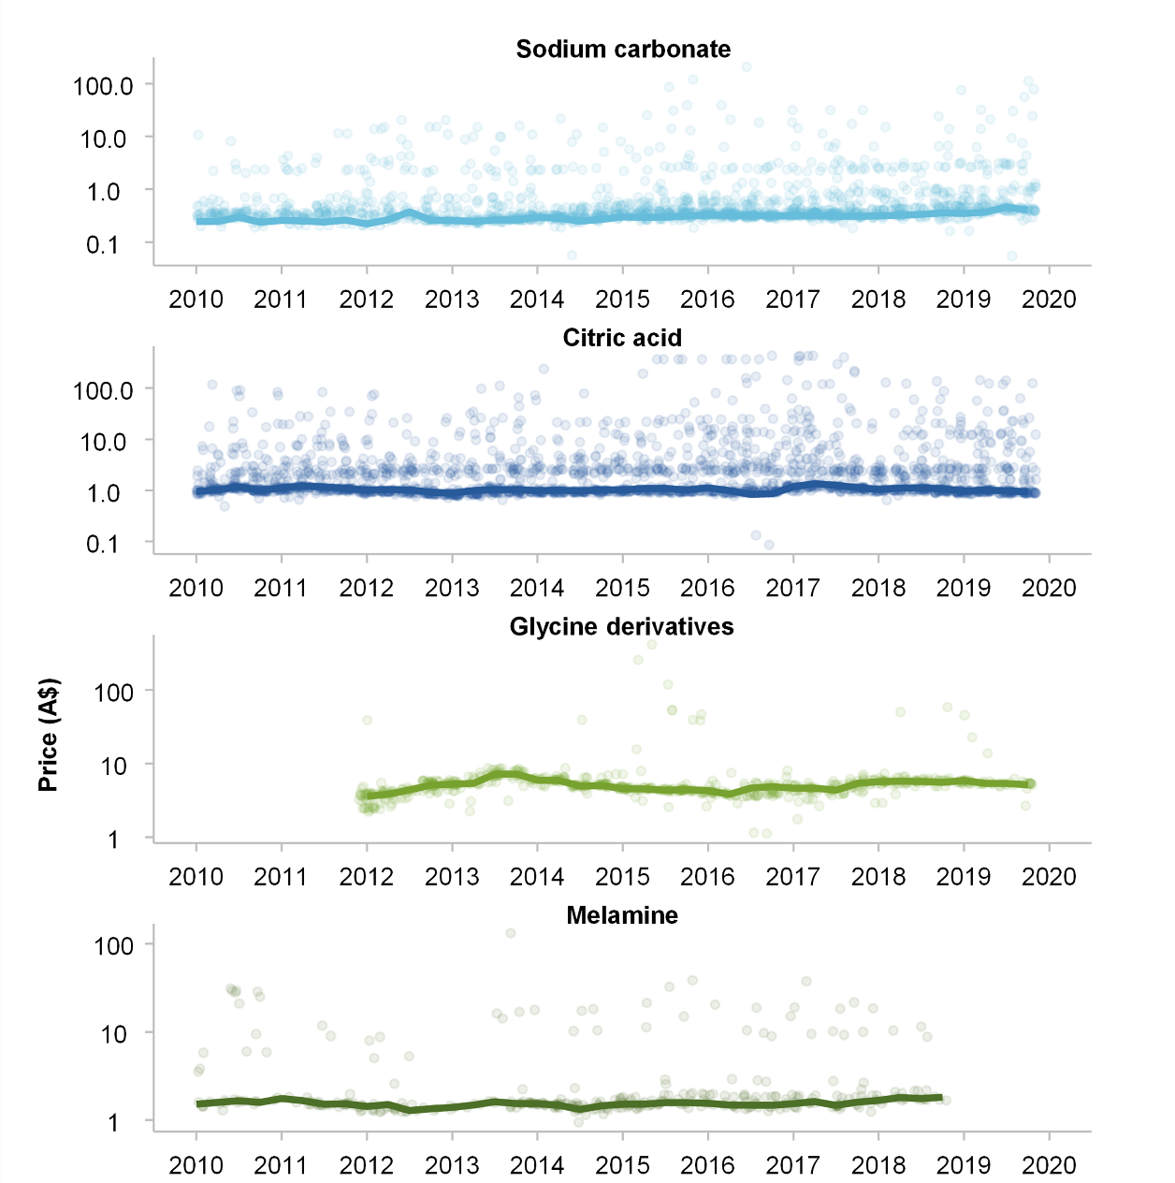

**a.** Jitter plots slightly perturb each point. **b.** Prices are unit values, derived from cost (including insurance and freight, CIF) divided by quantity. **c.** Prices presented on a log scale and outliers over $AUD1000 have been removed for readability. **d.** Weighted average price is denoted by the solid line.

Source: ABS (*Merchandise Imports and Import Clearances*, 2020, unpublished).

There are four main dimensions of differentiation.

First, there are likely to be volume discounts offered by the supplier of the chemical, as any shipment will involve some fixed costs. The prices of larger shipments are noticeably lower and a regression confirms that there is a negative price-volume relationship (figure 3). Prices can be up to ten times larger for small shipments. This effect will be particularly noticeable with shipments sent by air, which could arguably be considered a different product (involving very different fixed costs for the shipper). As a result, we have dropped air shipments from the estimation. We have also reproduced some of the regressions with the upper decile of price observations dropped, but the results did not change significantly.[8] Unfortunately we found that it is not possible estimate an elasticity while controlling for the price-shipment size effect; estimated elasticities would become positive. Presumably this is because buyers tend to order larger shipments when the price is low.

**Figure 3 – Bulk discounting in chemical importsa**

Scatterplot of price (per kg) by quantity of transaction (tonnes) for each chemical, 2010 to 2019

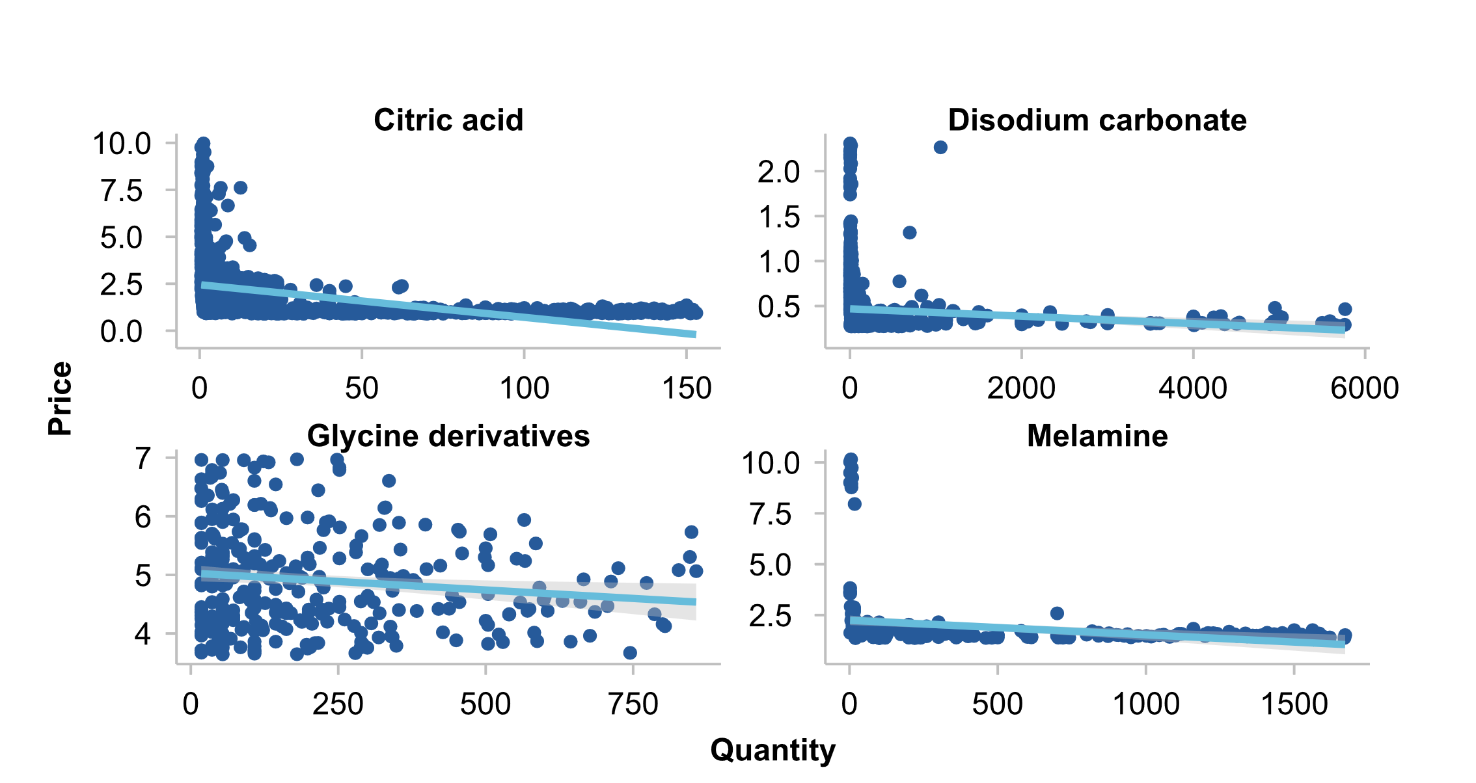

**a.** The bottom and top deciles of transactions were filtered out for both price and quantity to improve the readability of the figure.

Source: ABS (Merchandise Imports and Import Clearances, 2010–2019, unpublished).

Second, while a chemical is homogenous at the molecule level, it may be sold in different concentrations. The large variation in prices that we observe might indicate some heterogeneity in the products recorded. For example, a chemical could be sold in different concentrations, which would be reflected in their prices. Or the chemical may be sold in different physical forms (powder or liquid), which might affect the weight considerably (and hence the price per kilogram). While there is clustering around the weighted average price for some chemicals (figure 2), there is still considerable variation for what is assumed to be a homogenous group of products – or at least a group whose mix does not change markedly. Different concentrations would be an explanation. Customs forms would most likely have additional detail, but not the Merchandise Imports and Clearances dataset.

Third, some buyers will be purchasing under long-term contracts and may face very different prices to those purchasing on the spot market. There is no way to distinguish ‘spot prices’ and ‘long-term contract prices’ in this data.

Fourth, while the date of arrival into Australia is recorded, the date of purchase of the shipment is not recorded; thus, the purchases arriving in January 2010 may have been purchased at different times, when the market prices were different. Thus the "law of one price” may hold, but the price on arrival will reflect multiple prices.

Further investigation and discussion with purchasers are required to understand how prevalent each of these issues is. The first two issues render the elasticities that we estimate much less reliable. The latter two issues are less of a concern for the estimation, particularly as we are allowing for some autocorrelation in the data.

It is also important to understand the prevalence of each issue, as each has different implications for the impact of price spikes and for the vulnerability of different producers. If large firms are in long-term contracts and small firms are paying spot prices, then small firms are much more exposed to spikes in prices and possible financial difficulties. If small firms are paying much higher prices because they purchase small quantities, this would also imply vulnerability. If instead the small-quantity-high-price shipments are shipped to large firms with long-term contracts, who are simply ‘topping up’ their purchases, the consequences are minimal. It is certainly the case that high prices represent a very small share of total quantities purchased (figure 4).

**Figure 4 – Total quantity sold by price (with top-coding) for chemical importsa**

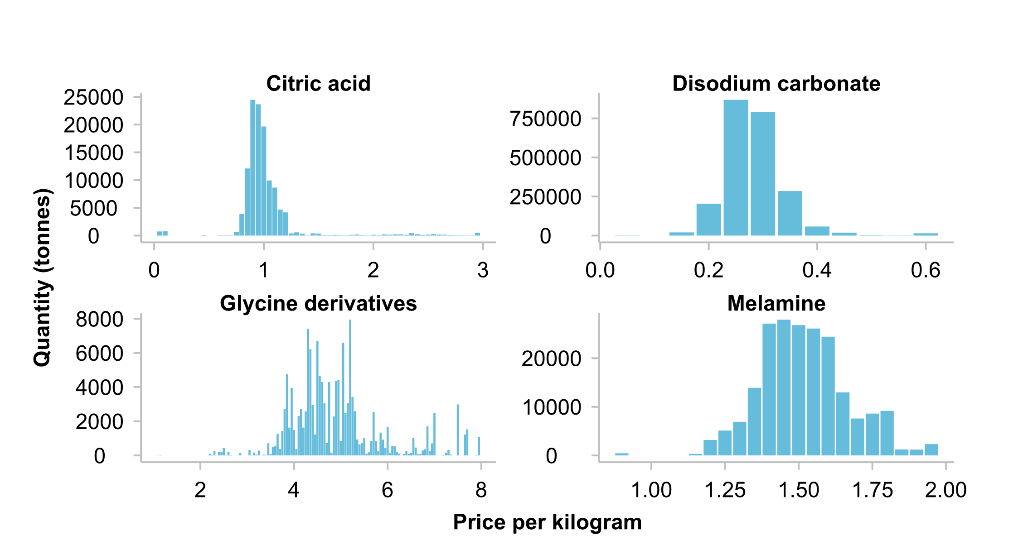

**a.** Sales above an arbitrary price limit were top-coded to that price limit, for readability: sales above $3.00 per kg for citric acid, above $0.65 for disodium carbonate, above $2.00 for melamine, and above $8.00 for glycine derivatives.

Source: ABS (Merchandise Imports and Import Clearances, 2010–2019, unpublished).

In order to proceed with the elasticity estimation, we aggregate the monthly ABS imports data into months (and into quarters for some of the regressions, for which less data is available). We derive unit values (prices) by dividing the good’s value (including insurance and freight) by its quantity. We then construct a weighted average price using quantity as the weights to create a price variable that accurately reflects the majority of purchases. But this methodology obscures the underlying heterogeneity in prices.

#### Autocorrelation and cointegration properties of the data

The four vulnerable chemicals analysed show a seasonal pattern in their demand (figure 5), so we include seasonal dummies in most of the regressions.

Figure 5 – Chemicals have annual and quarterly patterns

Kilograms (in millions) imported to Australia, quarterly for 2010 to 2019a

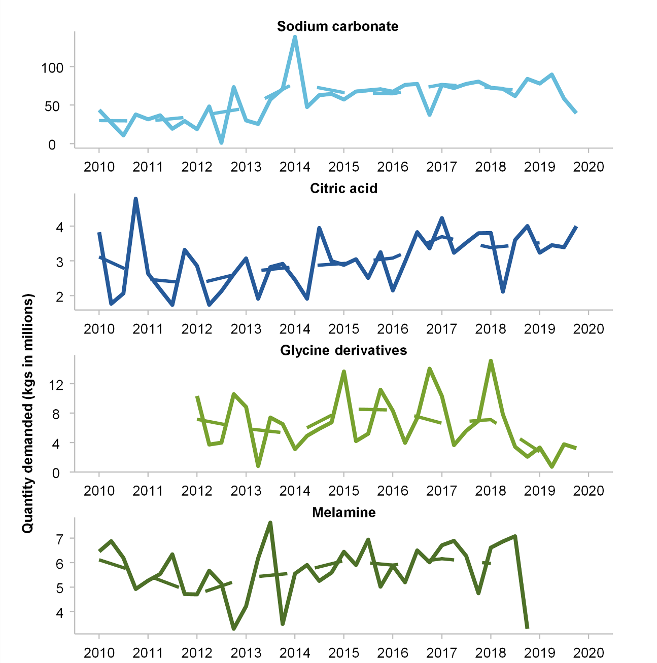

**a.** The dashed line represents the average quarterly imports for the year.

Source: ABS (*Merchandise Imports and Import Clearances*, 2020, unpublished).

Prices and quantities appear to exhibit substantial correlation over time, suggesting that a simple regression of log quantity on log price will be biased. An augmented Dickey-Fuller test shows that stationarity of both weighted average price and total quantity can be rejected, while it cannot be rejected that the first differences of these series are stationary.

We estimate demand elasticities for the four chemicals using two techniques that control for autocorrelation in the data: an autoregressive distributed lag model (ARDL), and, because the variables in the model are both stationary and cointegrated, we also estimate an error-correction model (ECM) (see appendix B for cointegration and stationarity results for citric acid). The results from both models are very similar.

#### Autoregressive distributed lag models

ARDL is a time series model which predicts current values of a dependent variable based on both current and lagged variables of the dependent and independent variables. ARDL is particularly useful when variables are integrated at different orders. The following ARDL equation (for log variables) is used to estimate demand elasticity for citric acid.

${logQ}_{t}=β_{0}+β_{1}{logP}_{t}+β_{2}M_{t}+\sum_{i=1}^{p}{δ_{i}}{logQ}_{t-i}+\sum_{i=1}^{q}{γ_{i}}{logP}_{t-i}+\sum_{i=1}^{z}{π_{i}}M_{t-i}+γ_{t}+ϵ_{t}$ (1)

Where:

*Qt* isquantity demanded at time t

$β_{0}$ is the constant

$β_{1}$ is the **coefficient of interest** and shows the short-run price elasticity of demand, which measures the percentage change in quantity demanded resulting from a 1% change in price

$β_{2}$ controls for current levels of the activity variable (in this case, log of aggregate food expenditure)

$δ_{i}$ are the autoregressive lags for the log quantity of citric acid imported at time period t-i

$γ_{i}$ are the lagged coefficients for log price at time t-i

$π_{i}$ are the lagged coefficients for the log activity variable at time t-i

$γ_{t}$ includes monthly dummy variables to control for seasonality

$ϵ_{t}$ is the error term.

The activity variable is intended to capture exogenous shifts in demand that might affect the precision of the elasticity estimate. In the case of citric acid, a food additive, any exogenous changes that affected total expenditure on food might reasonably affect demand for citric acid. As a result, we include food expenditure (and in some specifications, lags of food expenditure) as an explanatory variable. Food expenditure is only available quarterly; thus it was assumed to grow at a constant rate over the quarter in order to generate monthly observations from the quarterly data.

Care must be taken in choosing the activity variable as it should not be a proxy for the size of the specific industry of interest. For some inputs, such as diesel for the trucking industry, a price shock would impact the price of trucking overall and reduce the size of the industry. Including a measure of the size of the trucking industry in the regression would lead to an underestimate of the demand elasticity.

Table 4 presents the results for citric acid with monthly variables, while appendix C contains results when weighted price and quantity observations are constructed for each quarter. Results in appendix C are similar but less statistically significant, given the limited number of quarter observations. Using exchange rates as the activity variable yields similar regression results as well.

The following model specifications were estimated (see table 4 for results):

1. equation 1 with a lag length of one and without the activity variable ($M_{t}$)
2. equation 1 with a lag length of one and with the activity variable
3. equation 1 with optimal lag length for each variable determined by the Akaike Criterion (AIC), and without the activity variable
4. equation 1 with optimal AIC lag length for each variable and with the activity variable.

All of these specifications included month dummies.

**Table 4 – ARDL model results for citric acid at a monthly levela**

| Coefficient | Specification 1 | Specification 2 | Specification 3 | Specification 4 |
| --- | --- | --- | --- | --- |
| *Constant* | 8.92***  (1.32) | 0.64  (3.74) | 13.63***  (0.10) | -1.48  (4.10) |
| $$P_{t}$$ | -1.05***  (0.32) | -0.94***  (0.33) | -0.86**  (0.33) | -0.79**  (0.32) |
| $$M_{t}$$ |  | 1.93  (11.51) |  | -21.97  (23.20) |
| $$Q_{t-1}$$ | 0.34***  (0.10) | 0.24**  (0.11) |  |  |
| $$P_{t-1}$$ | 0.77**  (0.32) | 0.64*  (0.33) | 0.27  (0.34) | 0.20  (0.34) |
| $$P_{t-2}$$ |  |  | 0.57*  (0.33) | 0.64*  (0.32) |
| $$M_{t-1}$$ |  | -0.86  (11.49) |  | -17.07  (32.75) |
| $$M_{t-2}$$ |  |  |  | 48.34  (32.29) |
| $$M_{t-3}$$ |  |  |  | 30.14  (37.11) |
| $$M_{t-4}$$ |  |  |  | 1.78  (41.56) |
| $$M_{t-5}$$ |  |  |  | -28.54  (41.35) |
| $$M_{t-6}$$ |  |  |  | -49.46  (37.14) |
| $$M_{t-7}$$ |  |  |  | 5.39  (32.55) |
| $$M_{t-8}$$ |  |  |  | 13.31  (32.56) |
| $$M_{t-9}$$ |  |  |  | 19.76  (23.15) |
| N | 119 | 110 | 118 | 101 |
| Adj. R‑squared | 0.23 | 0.28 | 0.17 | 0.29 |

**a.** Data ranged from 2010 to 2019. The optimal number of lags for food expenditure was 9 (only one lag is reported in table), for price was 2, and no lags for quantity. The specifications that include food expenditure had fewer observations because data were only available up to the 1st quarter of 2019. Standard errors presented in parentheses. *** p<.01 ** p<.05 * p<.1.

Source: ABS (*Merchandise Imports and Import Clearances*, 2010–2019, unpublished); ABS (*Australian National Accounts: National Income, Expenditure and Product*, December 2022, Cat. no. 5206.0, table 8).

The results show that a 1% increase in the current price of citric acid would lead to a -0.78 to ‑1.05% immediate decrease in quantity demanded. Given the standard errors, it cannot be determined whether the elasticity of citric acid is greater or less than (-1) (i.e. elastic or inelastic), and it appears to be inelastic when taking into account that some of the price adjustment may occur with delay (i.e. when accounting for the effect of Pt-1). In Specifications 1 and 2, the coefficients on Price and lagged Price are both statistically different from zero, as is the sum of the two coefficients are all different from zero, which suggests that demand is not perfectly inelastic. But it cannot be rejected in Specification 3 and 4 that the sum of the price coefficients is zero. That said, the ARDL structure is not ideal for identifying the long-term adjustment to prices; we will consider an error correction model next.

The coefficients on the activity variable (food expenditure Mt) and its lags are not statistically different from zero, and the coefficients are improbably large in specification 4. Even the elasticity of more than 1 in specification 2 seems unlikely. Most likely this is the result of the interpolation of food expenditure from quarterly to monthly, leading to imprecise estimates. Appendix C re-runs the regressions for citric acid using data aggregated into quarterly rather than monthly observations; unfortunately none of the coefficients are significant, given the small number of observations.

Appendix C outlines the results of ARDL regressions for the other three chemicals: disodium carbonate, glycine, and melamine. Only quarterly results are presented for glycine and melamine, because of the smaller number of observations for those chemicals; and the results are very imprecise. Appendix C also provides results for two chemicals with large numbers of shipments recorded: calcium chloride and magnesium sulphate.

#### Error Correction Models

An ECM corrects for non-stationarity and time trends in the data. The model regresses the first difference of the dependent variable on the first difference of the independent variable (the short-run effect), and the lag of the dependent and independent variables (the long-run effect). This estimation thus provides the long-run and short run dynamics of demand elasticity. The regression is:

$Δlogq_{t}=β_{0}+β_{1} ΔlogP_{t}+β_{2}ΔlogM_{t}+β_{3}logP_{t-1}+β_{4}logq_{t-1}+β_{5}logM_{t-1}+γ_{t} +ε_{t}$ ( 2 )

where:

$α_{0}$ is the constant

$β_{1}$ is the short-run price elasticity of demand

$β_{2}$ controls for short-run changes in the activity variable

$β_{3} , β_{4} and β_{5} are$ the lagged coefficients for log price, log quantity and log activity variable at time t-1. This allows for an adjustment to long-run equilibrium

$γ_{t}$ represents monthly dummy variables

$ϵ_{t}$ is the error term.

A more structural version of equation (2), which allows us to see the relationship between the short run and the long-run relationship, is:

+ + ( 3 )

where the long run relationship is $logq_{t}=g+α_{2}\log{P_{t}+α_{3}logM_{t} }$

and $α_{1}=β_{4}, α_{2}=β_{3}, α_{3}=β_{5} , g=\frac{β_{0}-α_{0}}{β_{4}}$

The long-run part of the equation is represented by the brackets: $\log{q}= \frac{α_{2}}{α_{1}}logP+\frac{α_{3}}{α_{1}}logM+g$ should hold in long-run equilibrium, but there are short-run deviations from equilibrium. And $α_{1}$ is the adjustment term which indicates how strongly import demand responds to deviations away from the long-run relationship. The short-run part of the equation is represented by the first differenced terms.

The following model specifications – with a lag length of 1 - are included in table 5:

Specification 1 – equation 2 with only $β_{1}$, $β_{3}$ and $β_{4}$

Specification 2 – equation 2 with only $β_{1}$, $β_{3}, β_{4}$ and $γ_{t}$

The activity variable was not included in the monthly estimation, as food expenditure is a quarterly variable, and it is not reasonable to interpolate it and then first difference it. But we include it in quarterly estimation in appendix C.

All specifications showed no autocorrelation according to the Durbin-Watson test.

Table 5 – ECM results for citric acid at a monthly levela

|  |  |  |
| --- | --- | --- |
| Coefficient | Specification 1 | Specification 2 |
| *Constant* | 8.81***  (1.21) | 8.92***  (1.32) |
| $$ΔlogP_{t}$$ | -1.15***  (0.31) | -1.05***  (0.32) |
| $$logP_{t-1}$$ | -0.33  (0.31) | -0.28  (0.31) |
| $$logq_{t-1}$$ | -0.64***  (0.09) | -0.66***  (0.10) |
| N | 119 | 119 |
| Adjusted R‑squared | 0.41 | 0.46 |

**a.** Data ranged from 2010 to 2019. Standard errors presented in parentheses. *** p<.01 ** p<.05 * p<.1.

Source: Commission estimates based on ABS (*Merchandise Imports and Import Clearances*, 2020, unpublished).

The ECM results suggest that the short-term elasticity of demand is significantly different from zero. There is also correction towards the long-term relationship, as is common. Going by the interpretation in equation (3), the long-term elasticity of demand $-\frac{α_{2}}{α_{1}}$ lies around -0.42. However, given that some of the coefficients in the regression are not significant, the long-term elasticity of demand cannot be estimated with any precision. This is most likely due to the lack of homogeneity in the underlying data, discussed above.

The Error Correction Model (or some variant thereof) has been used in other papers which estimate import cost pass-through. Nakamura and Zerom (2019) (based on Goldberg and Campa 2010) included a dependent variable in log differences, because of the autocorrelation in the data. They also included lags of the independent variable, to allow for any time lags in adjusting to changes in the independent variable. However, no lags of the dependent variable are included, axiomatically. Their inclusion in autoregressive models is fairly common, and the fact that the coefficient is significant in both specifications above suggest that its inclusion is important to the accuracy of the model.

The quarterly ECM for citric acid, disodium carbonate, glycine and melamine are available in appendix C.

#### Limitations of the analysis

The fact that many firms buy imports from an intermediate industry (wholesalers and others) presents a challenge when estimating these elasticities. Another challenge in the estimation of an elasticity is that there may be domestic firms producing the same product, impacting the response to an import price shock.

In the presence of intermediaries, we may not be able to measure the amount imported by a particular industry. Consequently, the only sensible exercise may be to calculate an elasticity of total demand, rather than the demand elasticity of one industry. That exercise would still be useful for a product known to be used primarily by one industry, or if a product is used in a similar way in most industries. However, that assumption may not always be reasonable. For example, chlorine is imported to treat drinking water, an essential activity, and to treat water in swimming pools, which is nonessential; and the elasticity of demand is likely to be quite different for those sub-industries.

Local supply poses a separate challenge, as the dataset does not incorporate purchases of the product from local suppliers, and those purchases should change as well in response to an overseas price shock. The Merchandise trade data will also provide no indication as to whether there is a domestic source of supply; that information must be gathered from other sources.

1. Thoughts on new datasets

#### Census of manufacturing

The BLADE dataset, while remarkably useful in constructing an improved view of vulnerable imports, suffers from some limitations in the study of which industries use vulnerable imports, and in the study of the inflation impact of those imports. Only imported products, and the firms who first import them into Australia, are included in the merchandise trade data. As a result, BLADE cannot accurately capture the impact of an overseas price shock in one product on every Australian industry, as some industries will rely on intermediaries for their imports. And BLADE cannot capture domestic contagion, when a shock in one product price flows into other industries.

This places Australia at a disadvantage relative to other countries with more detailed manufacturing data. Even middle-income countries collect this data; for example, Mexico collects input and output data annually from manufacturing firms in the Encuesta Industrial Annual, as does Indonesia in selected years. Such a census could be developed for Australia but would only cover the approximately 5% of GDP covered by manufacturing. Such a survey would not provide a full picture of the economy, nor even of the industries that depend on overseas inputs. Sectors such as construction rely heavily on materials, and many essential services still rely on some products to deliver the service. General practitioner services in medicine, for example, rely critically on the availability of medicines and diagnostic test equipment. It would be more useful for the Australian Bureau of Statistics to develop a survey that covers manufacturing as well as the service sector, and that includes the non-market services of education, health, and government.

What types of data should be gathered in such a survey? A classification system for services of different types and skill levels is urgently needed. Firms could report on the prices charged for different services, and the wage bill for those services. And firms should report on their inputs, including any specialised services that they procure.

#### Price data

Lack of price data has posed consistent challenges for users of BLADE. While revenues and costs are available from tax information in BLADE, there are few volume measures in the dataset, and no price measures. Even measures such as wages that are common in other datasets are not available in BLADE; BLADE includes the total wage bill, and headcount, but no measure of which employees are full-time and which employees are part-time.[9] And there is no price information collected for the firm’s output. As discussed by McMillan and Burns (2021):

This absence of price or volume information makes BLADE difficult to use for certain purposes, such as estimating firm-level productivity or mark-up. Usually, in order to estimate productivity changes over time, prices of output must be held constant to prevent non-productivity related issues from affecting measures of output. For example, if one does not hold prices constant then changes in output (measured in terms of revenue minus intermediate input costs) may reflect changes in consumer demand or the degree of competition in the market.

The experience of this paper suggests that the usefulness of price data can be overstated. Even a commodity such as a chemical import that should be homogenous (indeed identical at a molecular level) shows significant heterogeneity. The date that the order was placed, the length of the contractual relationship, the size of the shipment, and the concentration of the chemical can all influence the price that is paid. As a result, even with price data it will be difficult to be certain that a product’s characteristics will remain constant over time. Short-run changes in price can be very informative about inflation; but in the longer run, there is the risk that the firm chooses to alter the characteristics of the product. Firms under cost pressure may reduce the quality of their product through various means. Firms may also raise prices by introducing and promoting new higher-quality products, with a higher margin, and eventually discontinuing the older product. Price data may allow for a correct estimate of markups (assuming that challenges in measuring capital costs can also be resolved), but there will continue to be challenges in measuring productivity.

### Summary

The merchandise trade data in BLADE has significant advantages relative to the approach in the *Vulnerable Supply Chains* (2021) report, which used the Australian National Accounts Input-Output tables published by the ABS to determine which industries used vulnerable goods. This allows for a systematic scan of industries and products which are vulnerable to supply shocks.

This data can be linked to information about importing firms to provide some insight into the likely impacts of price shocks or interruptions in supply of selected overseas products. It is possible to determine market reactions to price shocks, but these insights are limited because Australia does not have detailed data on the inputs and outputs of domestic firms.

Australia may want to develop a regular survey of firms that measures their inputs and their outputs in detail. Given the small share of manufacturing in the economy, it is important for this survey to include all sectors of the economy, not simply manufacturing. It should include agriculture, mining, manufacturing and all services, including the growing non-market service sector (education, health, and government). And care should be taken in constructing any price measures of inputs and outputs.

Appendix A: Essential industries selected at the ANZSIC 4-digit level

| **Essential industry** | **ANZSIC** | **ANZSIC description** | **Selected as Essential** |
| --- | --- | --- | --- |
| **Banking** | 6210 | Central Banking | No |
| 6221 | Banking | Yes |
| 6222 | Building Society Operation | Yes |
| 6223 | Credit Union Operation | No |
| 6229 | Other Depository Financial Intermediation | No |
| 6230 | Non-Depository Financing | No |
| 6240 | Financial Asset Investing | No |
| **Health** | 1841 | Human Pharmaceutical and Medicinal Product Manufacturing | Yes |
| 1842 | Veterinary Pharmaceutical and Medicinal Product Manufacturing | Yes |
| 8401 | Hospitals (Except Psychiatric Hospitals) | Yes |
| 8402 | Psychiatric Hospitals | Yes |
| 8511 | General Practice Medical Services | Yes |
| 8512 | Specialist Medical Services | Yes |
| 8520 | Pathology and Diagnostic Imaging Services | Yes |
| 8531 | Dental Services | Yes |
| 8532 | Optometry and Optical Dispensing | Yes |
| 8533 | Physiotherapy Services | Yes |
| 8534 | Chiropractic and Osteopathic Services | Yes |
| 8539 | Other Allied Health Services | Yes |
| 8591 | Ambulance Services | Yes |
| 8599 | Other Health Care Services n.e.c. | Yes |
| 8601 | Aged Care Residential Services | Yes |
| 8609 | Other Residential Care Services | Yes |
| 8710 | Child Care Services | Yes |
| 8790 | Other Social Assistance Services | Yes |
| **Water services** | 2811 | Water Supply | Yes |
| 2812 | Sewerage and Drainage Services | Yes |
| **Communications** | 5610 | Radio Broadcasting | Yes |
| 5621 | Free-to-Air Television Broadcasting | Yes |
| 5622 | Cable and Other Subscription Broadcasting | No |
| 5700 | Internet Publishing and Broadcasting | Yes |
| 5910 | Internet Service Providers and Web Search Portals | Yes |
| 5921 | Data Processing and Web Hosting Services | Yes |
| 5922 | Electronic Information Storage Services | Yes |
| 5801 | Wired Telecommunications Network Operation | Yes |
| 5802 | Other Telecommunications Network Operation | Yes |
| 5809 | Other Telecommunications Services | Yes |
| **Energy** | 600 | Coal Mining | Yes |
| 700 | Oil and Gas Extraction | Yes |
| 1701 | Petroleum Refining and Petroleum Fuel Manufacturing | Yes |
| 1709 | Other Petroleum and Coal Product Manufacturing | Yes |
| 2611 | Fossil Fuel Electricity Generation | Yes |
| 2612 | Hydro-Electricity Generation | Yes |
| 2619 | Other Electricity Generation | Yes |
| 2620 | Electricity Transmission | Yes |
| 2630 | Electricity Distribution | Yes |
| 2640 | On Selling Electricity and Electricity Market Operation | Yes |
| 2700 | Gas Supply | Yes |
| **Logistics** | 4610 | Road Freight Transport | Yes |
| 4621 | Interurban and Rural Bus Transport | No |
| 4622 | Urban Bus Transport (Including Tramway) | No |
| 4623 | Taxi and Other Road Transport | No |
| 4710 | Rail Freight Transport | Yes |
| 4720 | Rail Passenger Transport | No |
| 4810 | Water Freight Transport | Yes |
| 4820 | Water Passenger Transport | No |
| 5010 | Scenic and Sightseeing Transport | No |
| 5021 | Pipeline Transport | Yes |
| 5029 | Other Transport n.e.c. | Yes |
| 4900 | Air and Space Transport | Yes |
| 5211 | Stevedoring Services | Yes |
| 5212 | Port and Water Transport Terminal Operations | Yes |
| 5219 | Other Water Transport Support Services | Yes |
| 5220 | Airport Operations and Other Air Transport Support Services | Yes |
| 5291 | Customs Agency Services | Yes |
| 5292 | Freight Forwarding Services | Yes |
| 5299 | Other Transport Support Services n.e.c. | Yes |
| 5301 | Grain Storage Services | Yes |
| 5309 | Other Warehousing and Storage Services | Yes |
| 3311 | Wool Wholesaling | No |
| 3312 | Cereal Grain Wholesaling | No |
| 3319 | Other Agricultural Product Wholesaling | No |
| 3321 | Petroleum Product Wholesaling | Yes |
| 3322 | Metal and Mineral Wholesaling | No |
| 3323 | Industrial and Agricultural Chemical Product Wholesaling | Yes |
| 3331 | Timber Wholesaling | No |
| 3332 | Plumbing Goods Wholesaling | No |
| 3339 | Other Hardware Goods Wholesaling | No |
| 3411 | Agricultural and Construction Machinery Wholesaling | No |
| 3419 | Other Specialised Industrial Machinery and Equipment Wholesaling | No |
| 3491 | Professional and Scientific Goods Wholesaling | No |
| 3492 | Computer and Computer Peripheral Wholesaling | No |
| 3493 | Telecommunication Goods Wholesaling | Yes |
| 3494 | Other Electrical and Electronic Goods Wholesaling | No |
| 3499 | Other Machinery and Equipment Wholesaling n.e.c. | No |
| 3501 | Car Wholesaling | No |
| 3502 | Commercial Vehicle Wholesaling | Yes |
| 3503 | Trailer and Other Motor Vehicle Wholesaling | Yes |
| 3504 | Motor Vehicle New Parts Wholesaling | Yes |
| 3505 | Motor Vehicle Dismantling and Used Parts Wholesaling | Yes |
| 3601 | General Line Grocery Wholesaling | No |
| 3602 | Meat, Poultry and Smallgoods Wholesaling | No |
| 3603 | Dairy Produce Wholesaling | No |
| 3604 | Fish and Seafood Wholesaling | No |
| 3605 | Fruit and Vegetable Wholesaling | No |
| 3606 | Liquor and Tobacco Product Wholesaling | No |
| 3609 | Other Grocery Wholesaling | No |
| 3711 | Textile Product Wholesaling | Yes |
| 3712 | Clothing and Footwear Wholesaling | No |
| 3720 | Pharmaceutical and Toiletry Goods Wholesaling | Yes |
| 3731 | Furniture and Floor Covering Wholesaling | No |
| 3732 | Jewellery and Watch Wholesaling | No |
| 3733 | Kitchen and Diningware Wholesaling | No |
| 3734 | Toy and Sporting Goods Wholesaling | No |
| 3735 | Book and Magazine Wholesaling | No |
| 3736 | Paper Product Wholesaling | No |
| 3739 | Other Goods Wholesaling n.e.c. | No |
| 3800 | Commission-Based Wholesaling | No |
| 3911 | Car Retailing | No |
| 3912 | Motor Cycle Retailing | No |
| 3913 | Trailer and Other Motor Vehicle Retailing | No |
| 3921 | Motor Vehicle Parts Retailing | No |
| 3922 | Tyre Retailing | No |
| 4000 | Fuel Retailing | Yes |
| 4110 | Supermarket and Grocery Stores | No |
| 4121 | Fresh Meat, Fish and Poultry Retailing | No |
| 4122 | Fruit and Vegetable Retailing | No |
| 4123 | Liquor Retailing | No |
| 4129 | Other Specialised Food Retailing | No |
| 4211 | Furniture Retailing | No |
| 4212 | Floor Coverings Retailing | No |
| 4213 | Houseware Retailing | No |
| 4214 | Manchester and Other Textile Goods Retailing | No |
| 4221 | Electrical, Electronic and Gas Appliance Retailing | No |
| 4222 | Computer and Computer Peripheral Retailing | No |
| 4229 | Other Electrical and Electronic Goods Retailing | No |
| 4231 | Hardware and Building Supplies Retailing | No |
| 4232 | Garden Supplies Retailing | No |
| 4241 | Sport and Camping Equipment Retailing | No |
| 4242 | Entertainment Media Retailing | No |
| 4243 | Toy and Game Retailing | No |
| 4244 | Newspaper and Book Retailing | No |
| 4245 | Marine Equipment Retailing | No |
| 4251 | Clothing Retailing | No |
| 4252 | Footwear Retailing | No |
| 4253 | Watch and Jewellery Retailing | No |
| 4259 | Other Personal Accessory Retailing | No |
| 4260 | Department Stores | No |
| 4271 | Pharmaceutical, Cosmetic and Toiletry Goods Retailing | Yes |
| 4272 | Stationery Goods Retailing | No |
| 4273 | Antique and Used Goods Retailing | No |
| 4274 | Flower Retailing | No |
| 4279 | Other Store-Based Retailing n.e.c. | No |
| 4310 | Non-Store Retailing | No |
| 4320 | Retail Commission-Based Buying and/or Selling | No |
| **Government** | 7510 | Central Government Administration | Yes |
| 7520 | State Government Administration | Yes |
| 7530 | Local Government Administration | Yes |
| 7540 | Justice | Yes |
| 7551 | Domestic Government Representation | Yes |
| 7552 | Foreign Government Representation | Yes |
| 7720 | Regulatory Services | Yes |
| 7600 | Defence | Yes |
| 7711 | Police Services | Yes |
| 7712 | Investigation and Security Services | Yes |
| 7713 | Fire Protection and Other Emergency Services | Yes |
| 7714 | Correctional and Detention Services | Yes |
| 7719 | Other Public Order and Safety Services | Yes |

Appendix B: Stationarity and Cointegration tests

This appendix presents the results for the citric acid price and quantity variables in quarterly form; results for the other chemicals yielded similar results.

**Table B.1 – Results from Augmented Dickey-Fuller test on key variablesa**

| **Variable** | **ADF statistic** | **Stationary or non-stationary** |
| --- | --- | --- |
| Log weighted average price | -2.52 | Non-stationary |
| Weighted average price | -2.87 | Non-stationary |
| Log difference of weighted average price | -4.98 | Stationary |
| Log quantity | -2.86 | Non-stationary |
| Quantity | -2.94 | Non-stationary |
| Log difference of quantity | -8.82 | Stationary |

**a.** Stationary or non-stationary results are reported at the 5% significance level.

Source: ABS (*Merchandise Imports and Import Clearances*, 2010–2019, unpublished).

To test for cointegration, the Engle-Granger two-step method was chosen due to the small sample size. The Engle-Granger two-step method creates residuals based on the static regression and then tests the residuals for the presence of unit-roots (non-stationarity). It then tests for the stationarity of the residuals. If the time series is cointegrated, the Engle-Granger method will show the residuals to be stationary.[10]

Quarterly log quantity is regressed on log price, and quarterly log quantity is regressed on log price and log food expenditure. The residuals are then tested for stationarity.

$$\ln\left(q_{t}\right)=β_{0}+β_{1}ln\left(p_{t}\right)+ε_{t} \left(A\right)$$

$$\ln\left(q_{t}\right)=β_{0}+β_{1}ln\left(p_{t}\right)+β_{2}ln\left(m_{t}\right)+ε_{t} (B)$$

The Augmented Dickey-Fuller test showed that equations A and B were cointegrated based on the AIC number of lags (1) (table B.2). For lags greater than one, cointegration did not exist.

As a robustness test, the Johansen test was also performed and it found that there was evidence of at least one cointegrating relationship for log quantity and log price, and for log quantity, log price and log food expenditure.

Table B.2 – Results from the Engle-Granger two-step methoda

| **Specification** | **ADF test statistic** | **Critical value** | **Conclusion** |
| --- | --- | --- | --- |
| Equation A | -5.8 | -3.5 | Reject the null and conclude cointegration |
| Equation B | -5.3 | -3.5 | Reject the null and conclude cointegration |

**a.** Critical values are reported for the 5% level of significance.

Appendix C: Other regression results for chemicals

Results for Citric Acid (data aggregated into quarters)

In this section, we run the ARDL equations described in equation 1 with quarterly data instead of monthly. Sales are averaged over quarters rather than months, and the weighted average price in each quarter is constructed. Dummies are quarterly instead of monthly.

Using quarterly data allows us to use the activity variable (food expenditure) without interpolation. Using quarterly data can also smooth the impact of a shipment that is an outlier; but it also greatly reduces the number of observations.

The following model specifications were estimated (table C.1):

Specification 1: equation 1 with a lag length of one and without the activity variable ($M_{t}$)

Specification 2: equation 1 with a lag length of one and with the activity variable

Specification 3: equation 1 with optimal lag length for each variable determined by the Akaike Criterion (AIC), and without the activity variable

Specification 4: equation 1 with optimal AIC lag length for each variable and with the activity variable.

All of these specifications included month dummies.

Table C.1 – ARDL model results for Citric Acida

|  |  |  |  |  |
| --- | --- | --- | --- | --- |
| Variable | Specification 1 | Specification 2 | Specification 3 | Specification 4 |
| *Constant* | 12.09***  (2.58) | -1.03  (5.26) | 4.49  (4.05) | -1.76  (6.04) |
| $$P_{t}$$ | -0.37  (0.52) | -0.09  (0.49) | -0.64  (0.53) | -0.34  (0.74) |
| $$M_{t}$$ |  | 0.76  (8.58) |  | -24.30  (20.24) |
| $$Q_{t-1}$$ | 0.19  (0.17) | -0.12  (0.18) | 0.10  (0.17) | -0.13  (0.23) |
| $$Q_{t-2}$$ |  |  | 0.23  (0.17) | 0.09  (0.30) |
| $$Q_{t-3}$$ |  |  | 0.37  (0.19) | 0.13  (0.28) |
| $$P_{t-1}$$ | 0.46  (0.52) | 0.26  (0.47) | 0.13  (0.51) | 0.27  (0.54) |
| $$M_{t-1}$$ |  | 1.00  (8.62) |  | 61.62  (45.56) |
| $$M_{t-2}$$ |  |  |  | -68.64  (45.42) |
| $$M_{t-3}$$ |  |  |  | 32.86  (19.92) |
| N | 39 | 36 | 37 | 34 |
| Adj. R‑squared | 0.17 | 0.35 | 0.22 | 0.23 |

**a.** Data ranged from 2010 to 2019. The optimal lags for food expenditure were estimated to be 8, but given this was too many degrees of freedom, 3 was used instead. The specifications that include food expenditure had less observations because data were only available up to the 1st quarter of 2019. Standard errors presented in parentheses. *** p<.01 ** p<.05 * p<.1.

Source: ABS (*Merchandise Imports and Import Clearances*, 2010–2019, unpublished; *Australian National Accounts: National Income, Expenditure and Product*, December 2022, Cat. no. 5206.0, table 8).

None of the coefficients are significantly different from zero (and the coefficient on the activity variable and its lags is improbably large in Specification 4). This is most likely due to the small number of observations.

The ECM in equation 2 was also estimated with quarterly data:

Specification 1 – equation 2 with only $β_{1}$, $β_{3}$ and $β_{4}$

Specification 2 – equation 2 with only $β_{1}$, $β_{3}, β_{4}$ and $γ_{t}$

Specification 3 – equation 2 with only $β_{1}$, $β_{2} ,$ $β_{3}, β_{4}$ and $β_{5}$

Specification 4 – equation 2.

In all of these specifications, the lag length is restricted to 1, given the limited number of degrees of freedom. Again, significance was a challenge, given the small number of observations.

**Table C.2 – ECM results for citric acida**

|  |  |  |  |  |
| --- | --- | --- | --- | --- |
| Coefficient | Specification 1 | Specification 2 | Specification 3 | Specification 4 |
| *Constant* | 12.33***  (2.44) | 12.09***  (2.58) | -2.39  (5.88) | -1.03  (5.26) |
| $$ΔlogP_{t}$$ | -0.93*  (0.52) | -0.37  (0.52) | -0.70  (0.52) | -0.09  (0.49) |
| $$Δ\log{M_{t}}$$ |  |  | 4.99  (9.56) | 0.76  (8.58) |
| $$logP_{t-1}$$ | -0.02  (0.50) | 0.10  (0.47) | -0.08  (0.49) | -0.16  (0.45) |
| $$logq_{t-1}$$ | -0.83***  (0.16) | -0.81***  (0.17) | -1.07***  (0.17) | -1.12***  (0.18) |
| $$logM_{t-1}$$ |  |  | 1.80***  (0.65) | 1.76***  (0.58) |
| N | 39 | 39 | 36 | 36 |
| Adj. R‑squared | 0.46 | 0.54 | 0.57 | 0.66 |

**a.** Data ranged from 2010 to 2019. The regressions that include food expenditure had less observations as data were only available up to the 1st quarter of 2019. Standard errors presented in parentheses. *** p<.01 ** p<.05 *  p<.1.

Results for Disodium carbonate with monthly data

Table C.3 and C.4 reproduce the regressions in tables 4 and 5 respectively (the ARDL and ECM models with monthly data) but for disodium carbonate. In this case, the activity variable is an interpolated log GDP per capita series (interpolated because GDP is only available quarterly). Log price and log quantity were stationary in first differences and cointegrated.

**Table C.3 – ARDL model results for disodium carbonate at a monthly levela**

| Coefficient | Specification 1 | Specification 2 | Specification 3 | Specification 4 |
| --- | --- | --- | --- | --- |
| *Constant* | 10.54***  (1.75) | -244.59***  (50.21) | 1.78***  (5.10) | -145.05*  (84.78) |
| $$P_{t}$$ | -4.75***  (0.73) | -6.20***  (0.74) | -5.29**  (0.75) | -5.81***  (0.85) |
| $$P_{t-1}$$ | 4.78***  (0.73) | 1.61  (0.98) | 1.70*  (0.97) | 2.10*  (1.13) |
| $$P_{t-2}$$ |  |  | 0.26  (0.97) | -0.94  (1.13) |
| $$P_{t-3}$$ |  |  | 2.03**  (0.94) | 2.22*  (1.13) |
| $$P_{t-4}$$ |  |  | -0.24  (0.97) | 0.61  (1.17) |
| $$P_{t-5}$$ |  |  | 1.41  (1.01) | 0.89  (1.16) |
| $$P_{t-6}$$ |  |  | 0.91  (1.03) | 0.34  (1.15) |
| $$P_{t-7}$$ |  |  | -0.78  (1.01) | -1.43  (1.12) |
| $$Q_{t-1}$$ | 0.36***  (0.09) | 0.06  (0.11) | 0.02  (0.11) | -0.021  (0.12) |
| $$Q_{t-2}$$ |  |  | 0.12  (0.11) | 0.07  (0.12) |
| $$Q_{t-3}$$ |  |  | 0.11  (0.11) | 0.05  (0.11) |
| $$Q_{t-4}$$ |  |  | -0.04  (0.10) | -0.06  (0.12) |
| $$Q_{t-5}$$ |  |  | 0.08  (0.11) | 0.07  (0.11) |
| $$Q_{t-6}$$ |  |  | 0.24**  (0.11) | 0.10  (0.12) |
| $$Q_{t-7}$$ |  |  | 0.11  (0.11) | 0.06  (0.11) |
| $$Q_{t-8}$$ |  |  | 0.18**  (0.09) | 0.16*  (0.09) |
| $$Q_{t-9}$$ |  |  | 0.08  (0.09) | 0.11  (0.09) |
| $$M_{t}$$ |  | 47.36  (97.57) |  | -140.84  (270.33) |
| $$M_{t-1}$$ |  | -18.41  (97.21) |  | -0.47  (409.56) |
| $$M_{t-2}$$ |  |  |  | 793.68*  (484.06) |
| $$M_{t-3}$$ |  |  |  | -369.74*  (484.06) |
| $$M_{t-4}$$ |  |  |  | -24.75  (579.67) |
| $$M_{t-5}$$ |  |  |  | -1038.97*  (592.69) |
| $$M_{t-6}$$ |  |  |  | 615.09  (502.26) |
| $$M_{t-7}$$ |  |  |  | -169.45  (423.54) |
| $$M_{t-8}$$ |  |  |  | 947.87**  (429.31) |
| $$M_{t-9}$$ |  |  |  | -595.31**  (285.62) |
| N | 119 | 109 | 111 | 101 |
| Adj. R‑squared | 0.34 | 0.48 | 0.49 | 0.55 |

**a.** Data ranged from 2010 to 2019. The optimal number of lags for GDP was 9, for price was 2, and zero lags for quantity. Standard errors presented in parentheses. *** p<.01 ** p<.05 * p<.1.

Source: ABS (*Merchandise Imports and Import Clearances*, 2010–2019, unpublished); ABS (*Australian National Accounts: National Income, Expenditure and Product*, December 2022, Cat. no. 5206.0, table 1).

Again, the estimates of the responsiveness to GDP per capita and its lags is improbably large, suggesting that the interpolation is creating significant noise.

Reassuringly, the estimates of the coefficient on price are relatively consistent, and most of the results suggest that demand for disodium carbonate is significantly elastic. This lines up with the findings in PC (2021).

Table C.4 – ECM results for disodium carbonate at a monthly levela

|  |  |  |
| --- | --- | --- |
| Coefficient | Specification 1 | Specification 2 |
| *Constant* | 11.46***  (1.70) | 10.54***  (1.75) |
| $$ΔlogP_{t}$$ | -4.11***  (0.72) | -4.75***  (0.73) |
| $$logP_{t-1}$$ | -0.16  (0.74) | 0.02  (0.71) |
| $$logq_{t-1}$$ | -0.72***  (0.09) | -0.64***  (0.09) |
| N | 119 | 119 |
| Adjusted R‑squared | 0.41 | 0.46 |

**a.** Data ranged from 2010 to 2019. Standard errors presented in parentheses. *** p<.01 ** p<.05 * p<.1.

Source: Commission estimates based on ABS (*Merchandise Imports and Import Clearances*, 2020, unpublished).

As with citric acid, the ECM results show that the short-term elasticity of demand is different from zero. However, the coefficient on the lag of price is not significant, implying that the long-term relationship is not estimated with any precision.

Results using data aggregated into quarters yields similar results, but less significance, and coefficients on price terms that are smaller in magnitude.

Results for glycine and melamine with quarterly data

### Autoregressive distributed lags model (ARDL)

A summary of the following model specifications is reported in table C.5[11]:

Specification 1 – equation 1 with a lag length of one without the activity variable ($M_{t}$)

Specification 2 – equation 1 with a lag length of one with the activity variable

Specification 3 – equation 1 with optimal AIC lag length for each variable without the activity variable, GDP[12]

Specification 4 – equation 1 with optimal AIC lag length for each variable with the activity variable.

In these regressions, the activity variable was GDP per capita. Similarly to the results reported in PC (2021), the elasticity is not significant, or does not have the expected negative coefficient. This could imply that demand for these chemicals is highly inelastic, or, more likely, that the smaller number of shipments of these chemicals means that the data is more noisy. There are 339 shipments of melamine in the dataset, and 453 shipments of glycine. Further research into glycine and melamine is therefore warranted.

Table C.5 – ARDL model for melamine, and glycinea

| **Variable** | **Specification 1** | **Specification 2** | **Specification 3** | **Specification 4** |
| --- | --- | --- | --- | --- |
| **Melamine** | | | | |
| $$P_{t}$$ | 1.16**  (0.47) | 1.35**  (0.41) | 0.55  (0.44) | 0.88** (0.40) |
| N | 35 | 34 | 33 | 32 |
| R‑squared | 0.50 | 0.55 | 0.39 | 0.53 |
| **Glycine derivatives** | | | | |
| $$P_{t}$$ | 1.59  (1.28) | 0.78  (1.40) | -0.91  (0.70) | -0.92  (0.83) |
| N | 31 | 28 | 32 | 26 |
| Adj. R‑squared | 0.31 | 0.14 | 0.23 | 0.07 |

**a.** Data ranged from 2010 to 2019 (some chemicals had less data than others). The regressions that include GDP per capita had less observations as data were only available up to the 1st quarter of 2019. Standard errors presented in parentheses. *** p<.01 ** p<.05 * p<.1.

Source: ABS (*Merchandise Imports and Import Clearances, 2010-2019*, unpublished); ABS (*Australian National Accounts: National Income, Expenditure and Product,* December 2022, Cat. no. 5206.0, table 1).

### Error correction model (ECM)

The following ECM is used to estimate the demand elasticity for melamine and glycine.[13] The dependent variable is the log difference of quantity demanded at time t.

$Δlogq_{t}=β_{0}+β_{1} ΔlogP_{t}+β_{2}ΔlogM_{t}+β_{3}logP_{t-i}+β_{4}logq_{t-i}+γ_{t} +ε_{t}$ ( 2 )

The following model specifications – with a lag length of 1 - are summarised in table C.6:

Specification 1 – equation 2 with only $β_{1}$, $β_{3}$ and $β_{4}$

Specification 2 – equation 2 with only $β_{1}$, $β_{3}, β_{4}$ and $γ_{t}$.

**Table C.6 – ECM results for vulnerable chemicalsa**

| **Coefficient** | **Specification 1** | **Specification 2** |
| --- | --- | --- |
| **Melamine** | | |
| $$ΔlogP_{t}$$ | 0.63  (0.61) | 1.16***  (0.47) |
| $$logq_{t-1}$$ | -1.01***  (0.22) | -0.70***  (0.20) |
| N | 35 | 35 |
| Adj. R‑squared | 0.39 | 0.71 |
| **Glycine derivatives** | | |
| $$ΔlogP_{t}$$ | 1.86  (1.48) | 1.59  (1.28) |
| $$logq_{t-1}$$ | -0.77***  (0.20) | -0.67***  (0.20) |
| N | 31 | 31 |
| Adj. R‑squared | 0.43 | 0.60 |

**a.** Data ranged from 2010 to 2019 (some chemicals had less data than others). The regressions that include GDP per capita had less observations as data were only available up to the 1st quarter of 2019. Standard errors presented in parentheses. *** p<.01 ** p<.05 * p<.1.

No specifications with an activity variable were run, as differences in log GDP per capita becomes a stationary variable. Again, the results are insignificant or the elasticity is (improbably) estimated to be positive.

Other (non-vulnerable) chemicals with high volume data

To estimate demand elasticity, it is important to have many observations to improve the robustness of the results. Chemicals with ‘high volume’ data included calcium chloride and magnesium sulphate. Chemicals were defined as high-volume if they had at least 10 observations in each quarter, and at least nine years of quarterly data. These chemicals were used to estimate the ARDL and ECM models at a monthly level.

### ARDL monthly results[14]

**Table C.7 – ARDL monthly model for calcium chloridea**

| Variable | Specification 1 | Specification 2 | Specification 3 | Specification 4 |
| --- | --- | --- | --- | --- |
| *Constant* | 8.70***  (1.17) | -13.13  (8.61) | 9.60***  (1.49) | -16.53*  (8.95) |
| $$P_{t}$$ | -0.75***  (0.11) | -0.81***  (0.11) | -0.76***  (0.11) | -0.79***  (0.11) |
| $$P_{t-1}$$ | 0.49***  (0.12) | 0.29**  (0.13) | 0.43***  (0.14) | 0.20  (0.14) |
| $$P_{t-2}$$ |  |  | 0.13  (0.13) | 0.05  (0.14) |
| $$Q_{t-1}$$ | 0.36***  (0.09) | 0.16  (0.10) | 0.36***  (0.10) | 0.17  (0.10) |
| $$Q_{t-2}$$ |  |  | -0.05  (0.10) | -0.16  (0.10) |
| $$M_{t}$$ |  | -15.84  (23.01) |  | -20.82  (23.00) |
| $$M_{t-1}$$ |  | 18.63  (22.90) |  | 13.47  (31.78) |
| $$M_{t-2}$$ |  |  |  | 11.69  (32.35) |
| $$M_{t-3}$$ |  |  |  | -0.93  (23.44) |
| N | 119 | 109 | 118 | 107 |
| Adj. R‑squared | 0.48 | 0.52 | 0.47 | 0.54 |

**a.** Data ranged from 2010 to 2019 (some chemicals had less data than others). The regressions that include GDP per capita had less observations as data were only available up to the 1st quarter of 2019. Standard errors presented in parentheses. *** p<.01 ** p<.05 * p<.1.

Source: ABS (Merchandise Imports and Import Clearances, 2010–2019, unpublished); ABS (Australian National Accounts: National Income, Expenditure and Product, December 2022, Cat. no. 5206.0, table 1).

**Table C.8 – ARDL monthly model for Magnesium Sulphatea**

| Variable | Specification 1 | Specification 2 | Specification 3 | Specification 4 |
| --- | --- | --- | --- | --- |
| *Constant* | 7.68***  (1.34) | -49.89***  (12.37) | 4.74***  (1.73) | -52.60***  (14.34) |
| $$P_{t}$$ | -0.78**  (0.30) | -0.90***  (0.30) | -0.85***  (0.31) | -0.85***  (0.31) |
| $$P_{t-1}$$ | 1.13***  (0.29) | 0.49  (0.31) | 1.02***  (0.30) | 0.50  (0.32) |
| $$Q_{t-1}$$ | 0.49***  (0.09) | 0.18*  (0.10) | 0.45***  (0.09) | 0.25**  (0.11) |
| $$Q_{t-2}$$ |  |  | -0.07  (0.10) | -0.21**  (0.10) |
| $$Q_{t-3}$$ |  |  | 0.30***  (0.09) | 0.12  (0.10) |
| $$M_{t}$$ |  | -14.99  (27.31) |  | -7.67  (27.20) |
| $$M_{t-1}$$ |  | 21.93  (27.15) |  | 33.94  (37.73) |
| $$M_{t-2}$$ |  |  |  | -29.61  (37.87) |
| $$M_{t-3}$$ |  |  |  | 10.62  (27.27) |
| N | 119 | 109 | 118 | 107 |
| Adj. R‑squared | 0.31 | 0.41 | 0.35 | 0.41 |

**a.** Data ranged from 2010 to 2019 (some chemicals had less data than others). The regressions that include GDP per capita had less observations as data were only available up to the 1st quarter of 2019. Standard errors presented in parentheses. *** p<.01 ** p<.05 * p<.1.

Source: ABS (Merchandise Imports and Import Clearances, 2010–2019, unpublished); ABS (Australian National Accounts: National Income, Expenditure and Product, December 2022, Cat. no. 5206.0, table 1).

As with the other chemicals, the estimates of the effect of the activity variable are not very realistic, most likely because of the interpolation.

### ECM monthly results

Variables for calcium chloride and magnesium sulphate at the monthly level were stationary, and therefore, an ECM should not be estimated. However, the results are still included for comparison.

**Table C.9 – Monthly ECM results for Calcium Chloridea**

|  |  |  |
| --- | --- | --- |
| Coefficient | Specification 1 | Specification 2 |
| *Constant* | 8.10***  (1.16) | 8.70***  (1.17) |
| $$ΔlogP_{t}$$ | -0.81***  (0.10) | -0.75***  (0.11) |
| $$logP_{t-1}$$ | -0.41*** | -0.261* |
| $$logq_{t-1}$$ | -0.60***  (0.09) | -0.64***  (0.09) |
| N | 119 | 119 |
| Adj. R‑squared | 0.54 | 0.58 |

**a.** Data ranged from 2010 to 2019 (some chemicals had less data than others). Standard errors presented in parentheses. *** p<.01 ** p<.05 * p<.1.

Source: Commission estimates based on ABS (*Merchandise Imports and Import Clearances*, 2010–2019, unpublished).

**Table C.10 – Monthly ECM results for Magnesium Sulphatea**

|  |  |  |
| --- | --- | --- |
| Coefficient | Specification 1 | Specification 2 |
| *Constant* | 7.01***  (1.28) | 7.68***  (1.34) |
| $$ΔlogP_{t}$$ | -0.73**  (0.29) | -0.78**  (0.30) |
| $$logP_{t-1}$$ | 0.22  (0.27) | 0.35  (0.27) |
| $$logq_{t-1}$$ | -0.48**  (0.08) | -0.51***  (0.09) |
| N | 119 | 119 |
| Adj. R‑squared | 0.32 | 0.35 |

**a.** Data ranged from 2010 to 2019 (some chemicals had less data than others). Standard errors presented in parentheses. *** p<.01 ** p<.05 * p<.1.

Source: Commission estimates based on ABS (*Merchandise Imports and Import Clearances*, 2010–2019, unpublished).

Interestingly, Calcium chloride is the first chemical for which we can estimate the long-term relationship with precision, given that the coefficients on logPt-1 and logQt-1 are both significant.

Appendix D: Background to BLADE

What is BLADE?

BLADE is a ‘collection of integrated, linked longitudinal datasets’ of Australian businesses (Hansell and Rafi 2018, p. 133). It provides a framework for linking ABS business surveys with administrative data on business via an Australian Business Number (ABN). This makes BLADE the most comprehensive database on firms in Australia.

BLADE combines tax, trade, and intellectual property business data with ABS data to provide a better understanding of the Australian economy and business performance over time. It is constructed with partnerships between many government departments.

Available data (July 2020 release)

A summary of the data available in BLADE as at July 2020 is presented in figure D.1. Revisions of BLADE data are released annually. The main administrative data come from the ATO, forming the BLADE ‘core’. These data include business income and taxation data. More recently, administrative data on intellectual property (from IP Australia) and merchandise trade (from DHA, i.e. Customs) have also been linked to BLADE.

The ABS survey data includes, for example, the Economic Activity Survey, Business Characteristics Survey, Survey of R&D, and Energy Water Environment Survey. Any ABS business survey that uses the ABS common survey frame can, in theory, be integrated in BLADE.

Administrative data are longitudinal, with most administrative datasets covering the period 2001**‑**02 to 2018**‑**19, but most of the survey data are cross‑sectional and relate to selected years and selected firms.

### Merchandise trade data

Administrative merchandise trade data are available for 2003–04 to 2018–19. These data are sourced from customs declarations and collected by the DHA. The data is limited to transactions of goods only (that is, it excludes services). The data for imports and exports by firms (captured by ABNs) includes information such as the commodity type (10‑digit HTISC), country of destination/departure, and value.

**Figure D.1 – What is covered in BLADE?a**

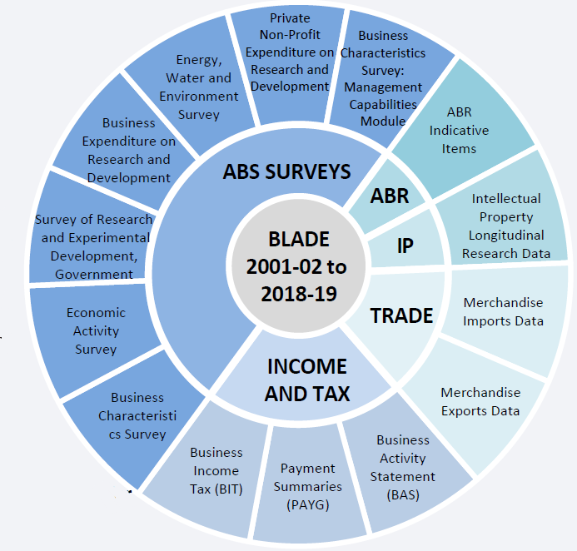

**a.** ABR = Australian Business Register is the whole-of-government register of businesses and is maintained by the ATO. It contains information on ABNs and related business information (location, business structure, industry, etc.).

Source: ABS (*BLADE Data Availability and Access*, User information pack, June 2020).

Coverage and scope

The July 2020 release of BLADE contains data on all active businesses from 2001–02 to 2018–19. There are two populations in the data:

* Non-profiled population, which are businesses with simple structures such that one ABN equates to one business. This covers the vast majority of businesses in BLADE.
* Profiled population, which are large, complex and diverse groups of businesses that are organised under Enterprise Groups (usually major and well-known companies, often with operations spread across industry divisions). The profiled population accounts for a small per cent of all ABN units, but a large per cent of output (Hansell and Rafi 2018, p. 134).

The number of firms (sample size) is dependent on which dataset is being used within BLADE. Administrative data have the broadest coverage, for example, in 2014–15 there were just under 2.4 million business income tax records (Hansell and Rafi 2018, p. 136). The coverage of the survey data depends on the scope of the survey. For example, in 2016–17 the Business Characteristics Survey sampled around 7,600 businesses (ABS source).

References

Amiti, M., Itskhoki, O. and Konings, J. (2014) ‘Importers, Exporters, and Exchange Rate Disconnect’, *American Economic Review*, vol. 104, no. 7, pp. 1942–1978.

Burrstein, A. M. Eichenbaum and S. Rebelo (2005). ‘Large Devaluations and the Real Exchange Rate’, *Journal of Political Economy* 113(4), 742-784

Dornbusch, R. (1987) ‘Exchange rate and prices’, *American Economic Review*, vol. 77, no. 1, pp. 93–106.

Feenstra, R., Gagnon, J. and Knetter, M. (1996), ‘Market Share and Exchange Rate Pass-Through in World Automobile Trade’, *Journal of International Economics*, vol. 40, pp. 187–207.

Feenstra, R. and Weinstein, D. (2017) ‘Globalization, Markups and U.S. Welfare’, *Journal of Political Economy* vol. 125, no. 4, pp. 1040–1074.

Goldberg, L. and Campa, J. (2010) ‘The Sensitivity of the CPI to Exchange Rates: Distribution Margins, Imports Inputs and Trade Exposure,’ *Review of Economics and Statistics*, vol. 92, pp. 392–407.

Goldberg, P. and F. Verboven (2001). ‘The Evolution of Price Dispersion in the European Car Market’, Review of Economic Studies 68, 811-848.

Hellerstein, R. (2008) ‘Who bears the cost of a change in the exchange rate? Pass-through accounting for the case of beer.’ Journal of International Economics 76, 14-32.

Hillberry, R. and Hummels, D. (2013) ‘Trade Elasticity Parameters for a Computable General Equilibrium Model’, in Dixon, P.B. and Jorgenson, D.W. (eds), *Handbook of Computable General Equilibrium Modelling*, vol. 1, Elsevier, Oxford, UK, pp. 1213–1269.

McMillan, H. and Burns, C. (2021) *BLADE for Productivity Research*, Productivity Commission Staff Working Paper, May.

Nakamura, E. and Zerom, D. (2010) ‘Accounting for Incomplete Pass-Through’, *Review of Economic Studies*, vol. 77, pp. 1192–1230.

Pennings, S. (2017), ‘Pass-through of Competitors’ Exchange Rates to US Import of Producer Prices’, *Journal of International Economics*, vol. 105, pp. 41–56.

Productivity Commission (2021) *Vulnerable Supply Chains*, Study Report, July.

1. Michael Brennan, Productivity Commission Chair, presented this paper to the Australian Bureau of Statistics and Reserve Bank of Australia joint conference on ‘Underneath the headlines: understanding price change in the Australian economy’, held 22–23 May 2023.
2. BLADE disclaimer. The results of these studies are based, in part, on Australian Business Registrar (ABR) data supplied by the Registrar to the ABS under *A New Tax System (Australian Business Number) Act 1999* and tax data supplied by the ATO to the ABS under the *Taxation Administration Act 1953*. These require that such data is only used for the purpose of carrying out functions of the ABS. No individual information collected under the Census and Statistics Act 1905 is provided back to the Registrar or ATO for administrative or regulatory purposes. Any discussion of data limitations or weaknesses is in the context of using the data for statistical purposes and is not related to the ability of the data to support the ABR or ATO's core operational requirements. Legislative requirements to ensure privacy and secrecy of these data have been followed. Source data are de-identified and so data about specific individuals or firms has not been viewed in conducting this analysis. In accordance with the Census and Statistics Act 1905, results have been treated where necessary to ensure that they are not likely to enable identification of a particular person or organisation.
3. See appendix D for a more detailed description of BLADE.
4. To identify products for which the world trade was concentrated, the Commission used world trade data published by COMTRADE. Unfortunately, this data is available only at the six-digit HTISC level. The Commission checked whether the six-digit HTISC category to which an import belonged was globally concentrated, in the sense that one country exported 50% or more of the product, or the Herfindahl-Hirschman index was above 3100 when each country was treated as one ‘producer’.
5. Australian National Accounts: Input-Output Tables, 2016–2017, Cat. No. 5209.0.55.001 (ABS).
6. The ABS omits some transactions in BLADE for confidentiality reasons. However, the ABS has tables that give an approximation of how much each industry is affected by these omissions.
7. In practice, however, ‘costs’ as reported to the Australian Taxation Office can reflect tax-minimising practices rather than the production process. Costs will also include investment costs rather than merely production costs, and the distinction is not always clear. This can produce misleading results. One possible solution is to measure expenditure on this input as a share of *revenue* rather than *cost*, as there is generally less discretion in the timing of revenues than costs.
8. The quarterly citric acid regressions were replicated without quantity outliers: the top 10% and the bottom 10% of size of shipments were omitted. The regression yielded very similar results. Likewise, the quarterly regressions for disodium carbonate, melamine and glycine yielded very similar results with or without quantity outliers. But the quarterly citric acid regressions without price outliers (i.e. without the top 10% and bottom 10% of prices) yielded much larger elasticities, possibly because large volumes are sold at the lowest prices and therefore there is less variation in weighted average prices when those observation are included.
9. The Linked Employer-Employee Dataset LEED used internally by Treasury, which incorporates the information in BLADE and also in personal tax data, overcomes this particular challenge.
10. The limitation of the Engle-Granger method is that if there are more than two variables, the method may show more than two cointegrating relationships. Another limitation is that it is a single equation model. However, some of the drawbacks have been addressed in recent cointegration tests such as the Johansen and Phillips-Ouliaris tests. The Johansen test is used to test cointegrating relationships between several non-stationary time series data. Compared to the Engle-Granger test, the Johansen test allows for more than one cointegrating relationship. However, it is subject to asymptotic properties (large sample size) since a small sample size would produce unreliable results. The Johansen test was also applied, to verify the Engle-Granger results. The Phillips-Ouliaris tests consists four distinct tests. Two are similar to the Engle-Granger test, only using a Phillips & Perron-like approach replaces the lags in the ADF test with a long-run variance estimator. The other two use variance-ratio like approaches to test. In both cases the test stabilizes when there is no cointegration and diverges due to singularity of the covariance matrix of the I(1) time series when there is cointegration.
11. For Disodium carbonate, specification 4 and 5 showed evidence of autocorrelation. For melamine, specification 1, 3 and 5 showed evidence of autocorrelation.
12. AIC lag lengths were restricted to a maximum length of three to help improve the degrees of freedom in the model. For example, if the AIC lag length was estimated to be 6, only 3 lags was used in the model.
13. Log price and log quantity were stationary and cointegrated for each chemical.
14. Specification 1 had evidence of autocorrelation at the 95% confidence interval for both Calcium Chloride and Magnesium sulphate.