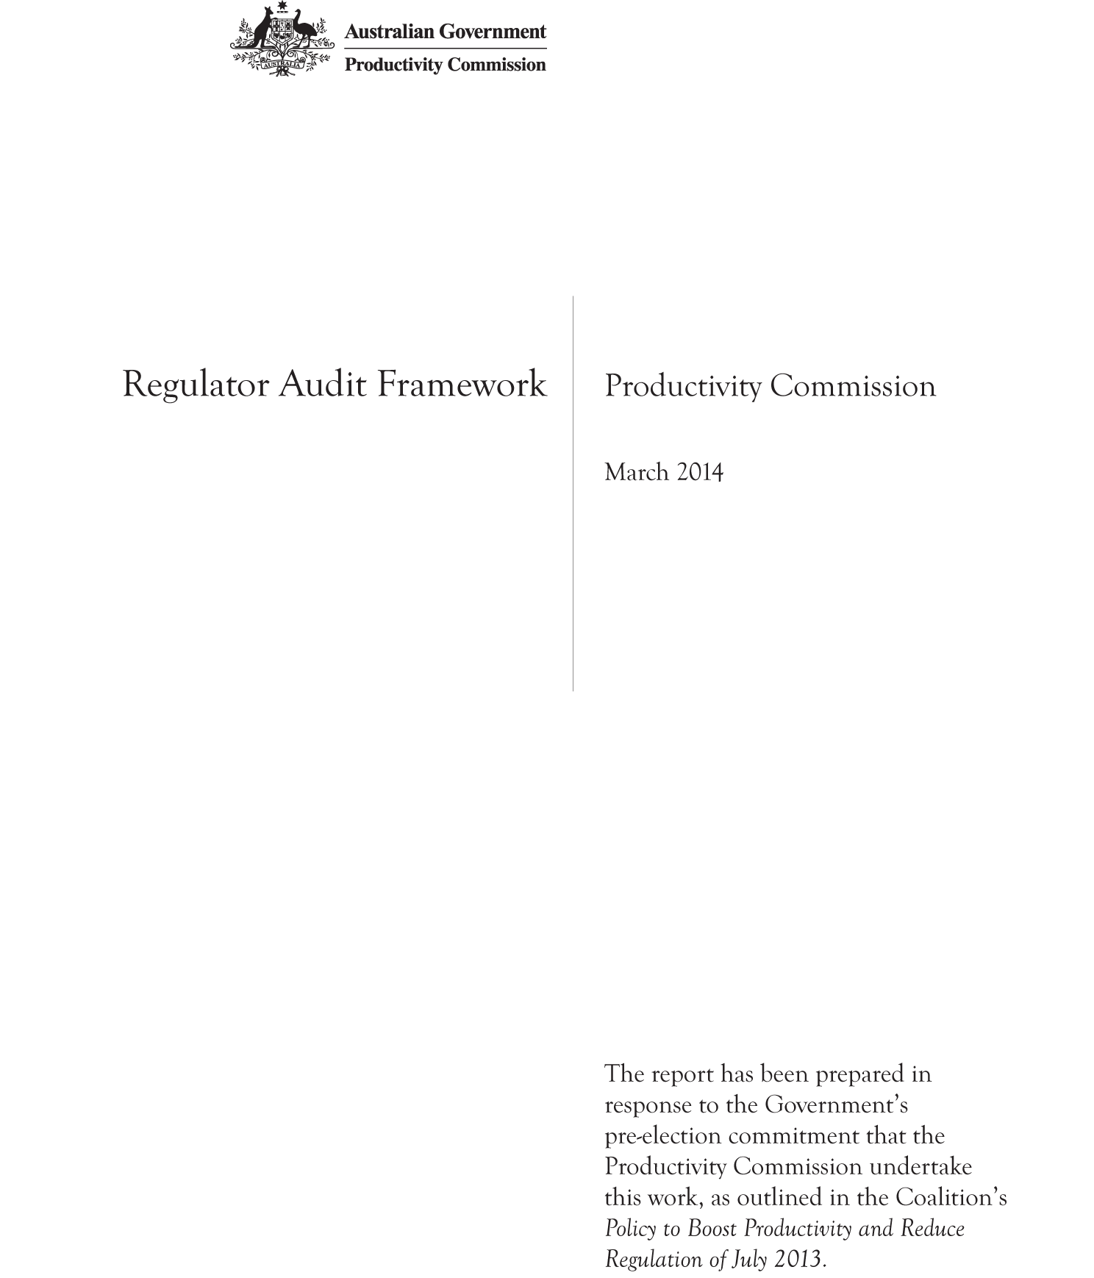

Commonwealth of Australia 2014
This work is copyright. Apart from any use as permitted under the Copyright Act 1968, the work may be reproduced in whole or in part for study or training purposes, subject to the inclusion of an acknowledgment of the source. Reproduction for commercial use or sale requires prior written permission from the Productivity Commission. Requests and inquiries concerning reproduction and rights should be addressed to Media and Publications (see below).
This publication is available from the Productivity Commission website at www.pc.gov.au. If you require part or all of this publication in a different format, please contact Media and Publications.
Publications Inquiries:
Media and Publications
Productivity Commission
Locked Bag 2 Collins Street East
Melbourne VIC 8003
Tel: (03) 9653 2244
Fax: (03) 9653 2303
Email: maps@pc.gov.au
General Inquiries:
Tel: (03) 9653 2100 or (02) 6240 3200
An appropriate citation for this paper is:
Productivity Commission 2014, Regulator Audit Framework, Canberra.
The Productivity Commission
The Productivity Commission is the Australian Government’s independent research and advisory body on a range of economic, social and environmental issues affecting the welfare of Australians. Its role, expressed most simply, is to help governments make better policies, in the long term interest of the Australian community.
The Commission’s independence is underpinned by an Act of Parliament. Its processes and outputs are open to public scrutiny and are driven by concern for the wellbeing of the community as a whole.
Further information on the Productivity Commission can be obtained from the Commission’s website (www.pc.gov.au) or by contacting Media and Publications on (03) 9653 2244 or email: maps@pc.gov.au

Summary
The framework set out in this paper provides guidance for auditing the performance of regulators in regard to the compliance costs they impose on business and other regulated entities. It complements other frameworks that are used to assess the performance of regulators in regard to their efficiency and effectiveness, and processes for ex ante assessment of the impact of proposed regulations. The framework should be applied within institutional arrangements that establish the authority, resources, and mechanisms to hold regulators to account.
For audits to improve regulator performance in this regard they need to:
- develop an audit plan in consultation with business and other stakeholders. This document should set out how the regulator will reduce compliance costs (good practice indicators), and how their achievement of this objective will be assessed (metrics)
- reward good performance and sanction poor performance
- comply with, and report against, the high level principles for good performance
- be public documents, with the audit plans and reports made available on the regulator’s website.
In order for the audits to be undertaken in an effective and efficient way they should:
- focus on the principles and particular areas of regulator behaviour that have the greatest effect on the cost of compliance for businesses they regulate — these will differ across regulators
- select good practice indicators that best reflect regulator behaviour that minimises compliance costs while still achieving the objectives of the regulation
- provide metrics at the highest level possible to demonstrate the satisfaction of the principle or indicator, utilising data and information from existing sources where available
- require auditors to ‘triangulate’ information in forming a view of the satisfactory achievement of a principle
- be included as a separate module in external audits that examine broader areas of performance of the regulator and regulation.
As part of the broader system that promotes regulation reform and reduces regulatory burden, oversight is needed to:
- ensure that audit plans are prepared and that both plans and audit reports are published
- coordinate the development of audit plans and audits to minimise the costs to business of participating in the process, and prioritise resources to where the potential for improvement is greatest
- facilitate feedback on the quality of the regulations and need for reform
- publish a report card facilitating comparison of the performance of regulators and lessons on approaches that have worked well in reducing compliance costs.

1 Introduction
This document sets out a framework that can be used to evaluate the performance of government regulators in regard to the compliance costs their behaviour imposes on the entities they regulate. It complements the Australian National Audit Office (ANAO) framework developed to audit the performance of regulators in regard to their administrative efficiency and their effectiveness in achieving the objectives of the regulation. This framework has been produced in response to a commitment by the Federal Government that the Productivity Commission develop such a framework, and that the Office of Best Practice Regulation (OBPR) use the framework to audit the performance of Commonwealth Government regulators at least once each parliamentary term (Liberal Party of Australia 2013, p. 22). This is part of the deregulation agenda of the Government, which seeks to lower cost, simplify regulation, and promote the use of non-regulatory solutions.
The need for an additional process to audit regulator performance reflects ongoing concerns that it is the way some regulators interact and engage with businesses and other regulated entities on a day to day basis that is responsible for much of the unnecessary cost imposed by regulation. For example, concerns have been raised by the Government about:
… many instances of regulators providing incorrect and inconsistent guidance and advice. This poor advice results in businesses having to pay costly fees for consultants or accountants to navigate the maze of regulation. At times, this has also resulted in businesses or individuals finding themselves subject to legal proceedings or penalties for actions, which they took in good faith, based on advice about regulatory requirements provided to them by bureaucrats who later turned out to be mistaken. (ibid, p. 21)
Similar concerns relating to regulators’ interaction with business were raised in a recent Commission study (PC 2013). Concerns were raised about the culture of regulators, and the extent to which the culture espoused by leaders flowed through to implementation ‘on the ground’. It was found that regulator behaviour can potentially have as large an effect on the compliance costs for business as the regulations themselves.
As a result, there is a case to consider adding an additional element into audits of regulator performance, that focuses on the way in which regulators interact with businesses.
Regulators can also play a role in improving the regulation they administer where they have the discretion to do so, and through the advice they provide to their policy department about the need for, and effectiveness of, the legislation.

Where does the PC audit framework fit in?
While existing audit processes address important questions such as the administrative efficiency of the regulator and the achievement of regulatory outcomes, there is no systematic process by which the costs that regulators impose on business are assessed ex post (see table 1). The proposed framework is designed to bridge this gap. It does not provide a guide to measuring the compliance costs, rather it takes a principles based approach. Adherence to these well-established principles should ensure that regulators are administering their regulations in a way that imposes least cost on business while still achieving the objectives of the regulation.
The framework set out in this paper is tightly focused on the performance of regulators in regard to compliance costs for business that are the result of the way in which the regulations are administered. It complements the ANAO’s Better Practice Guide: Administering Regulation, which is currently being updated. This guide and the ANAO’s pilot project The Australian Government Performance Measurement and Reporting Framework cover a much wider set of issues, including the organisational efficiency of the regulator, and the effectiveness of the regulation (whether it achieves its objectives).
The implementation of the Public Governance, Performance and Accountability (PGPA) Act 2013 will introduce new reporting requirements for regulators and departments. The form these will take is being developed by the Department of Finance. It is envisaged that reporting against the framework set out in this paper will form an input into this broader reporting process.
There are several other processes that may consider the costs that regulations impose on business. All new Commonwealth regulation that is expected to have a significant impact on business is required to have a regulatory impact assessment by the OBPR, and the states have similar requirements. However, ex-post, there is rarely a requirement to review the compliance costs on business. Audits of regulators by the ANAO, Departmental reviews (including those related to sunsetting legislation), and other ad hoc reviews could be asked to consider including compliance costs. This could be part of examining whether the regulation is efficient, effective and necessary.
Together these processes, set out in table 1, form the basis of the whole of government risk-management framework in regard to regulation. The framework presented in this paper is only a small part of this broader framework. Previous Commission reports have pointed to areas that need strengthening or where gaps remain. In particular the regulatory impact statement process, while sound on paper, was found to be less than ideal in practice (PC 2012), and processes for dealing with reviewing regulation (management of the stock of regulation) could be strengthened and gaps addressed (PC 2011). These issues are considered further in chapter 3 of this paper.
Table 1. Outline of processes to manage the risk of poor regulation
Assessment focus | Key issues | Processes and responsible entities
Regulation design and development | Are the regulatory objectives in the public interest?  Are regulations the best way of achieving the regulatory objectives?  Are regulations designed and implemented to allow compliance at least cost? | Policy departments, Office of Best Practice Regulation  Regulatory Impact Statement (RIS) process for regulations that have a non-minor impact on businesses, not-for-profit organisations and the community
Administration of the regulation | Is the regulator efficient?  Is there an unnecessary burden on businesses and other regulated entities? | Departmental and ANAO Audits  Currently there is no systematic approach to auditing compliance costs
Regulatory outcomes | Are regulatory objectives being achieved?  Are they being achieved at least cost? | ANAO Performance Audits  Ad hoc Departmental reviews
Regulatory impact | Is the regulation in the public interest? (cost-benefit test) | Ad hoc review processes, such as Productivity Commission Inquires  Sunsetting requirements overseen by Attorney Generals

As mentioned, the framework does not provide a method for estimating compliance costs. A guide to the estimation of the compliance costs of regulation (including the standard cost calculator tool) is already available from OBPR. Rather the framework aims to provide the basis of an ongoing process to build incentives for regulators to minimise the costs they impose on business (subject to regulatory effectiveness), and enhance their capacity to do so.

What are the objectives, outcomes and potential benefits?
The objective of the framework is to provide a platform for comprehensive assessment of individual regulators performance in regard to their interaction and engagement with businesses. The framework is intended to be adaptive to account for differences in the scope and scale of activities conducted by regulators. By providing a clear guide to practices that should minimise the compliance costs the regulator imposes, the application of the framework should give both guidance to the regulator on how to behave, and supply a way to assess their performance in regard to unnecessary compliance costs.
Successful implementation of the framework should ensure that good regulator practices are rewarded and encouraged, while bad practices are identified and discouraged. Improved regulator practices should avoid unnecessary compliance costs for businesses, and potentially lower administrative costs for regulators, without compromising regulatory outcomes. Broader benefits to the economy (beyond lower administration and business compliance costs) can also be expected if successful implementation of the framework leads to improved regulatory outcomes. This will depend, in part, on the scope the regulator has, and/or the willingness of the policy department, to act on any suggestions for regulatory reform.

What are the potential costs?
The costs of introducing a new process for auditing regulator performance could be substantial for both regulators and the auditor. Additional costs to business (or their representative bodies) can also be expected. The need to minimise these costs — particularly those associated with implementing and operating the framework — is of primacy in the current budget circumstances, and more generally from an efficient government perspective.
To help reduce costs the framework is designed to utilise available information, and only require the collection of new information where essential. Drawing on structured hypothesis testing methods, it adopts a hierarchical approach to the choice of indicators used to assess regulator performance in order to streamline the audit process and cut costs (Matthews and White 2013).
The framework is designed to be flexible so that it can be applied by any regulator in developing their own plan for improvement. While such planning should be part of normal practice, involving stakeholders in this process does involve additional costs. Hence the use of the framework to develop a ‘audit plan’ should be phased in across regulators based on the potential for improvement and scope for behaviour change to reduce compliance costs. For regulators that already undertake regular self-assessment, they should be given time to transition to the adoption of the framework.
External audit processes can be costly and need to be used judiciously. Governments should develop an overarching approach that combines annual regulator reports, and external audits that could be random or programmed. It is important to balance the incentives provided by external audits with the cost of these audit processes. As minimising the costs imposed on business is only one aspect of ensuring regulations are appropriate, efficient and effective, the application of this framework should, where possible, be undertaken as part of a process that considers these broader issues.
As businesses are usually regulated by a number of different regulators, there may be cost savings by coordinating external audits of regulator behaviour. This can be important where there are considerable interactions in the nature of the regulations and compliance requirements across regulators.

Implementation is critical
The framework is only a component of the process needed to improve regulator performance. It must be applied within institutional arrangements that establish the authority, resources, and mechanisms to hold regulators to account.
In light of some recent developments in this space (for example, the implementation of the PGPA Act, the establishment of Deregulation Divisions in each department, and new Government portfolio advisory groups), this paper also includes a chapter on how the proposed framework might be implemented in practice. Questions addressed include:
- who undertakes the audits and how often they are undertaken
- how to ensure that the audits improve regulator performance, and provide feedback on the need for the regulation and better regulatory approaches
- what processes ensure quality and reliability?
While a number of implementation options are canvassed, adoption of the appropriate pathway will ultimately be a choice for the Government. However, the Commission is of the view that substantial departure from the structure outlined is not likely to prove beneficial.

Essential components of a successful audit process
The framework provides a set of best-practice principles against which the performance of each regulator should be assessed, along with a range of possible indicators and metrics that could be used to make these assessments. However, a successful audit process involves more than just the framework. Irrespective of who ultimately conducts the audit, success in improving regulator behaviour will depend on a number of important steps being taken:
- Establishment of an agreed set of indicators of good performance that are appropriate to each regulator. This is the population of the framework for each regulator depending on what is assessed as being the most important elements for their performance, and what are the best indicators or measures of their performance. This should be documented as an audit plan. It should form part of a regulator’s stated intent for administering their regulations in a way that imposes the least costs on business. Plans that set out the timing for review activities can facilitate business engagement in the audit process by giving considerable prior notice, while publishing the proposed measures of intended performance can invite greater business response.
- Collection of information and data on the chosen indicators. The audit plan should set out what data should be collected for annual reporting, as well as the form in which it should be collected and collated. Some data will need to be collected on an ongoing basis, other data and information can be collected at the time of an external audit.
- Conduct of an external audit. This involves:
  - any further data collection and consultation
  - drafting of a written assessment of the regulator’s performance against the best-practice principles
  - validation that the indicators and assessment accurately reflect the most important aspects of regulator performance in regard to the costs they impose on business
  - publication of the audit report in a central location.
While these steps mostly apply whether using the proposed framework or a key performance indicator (KPIs) approach, there are several fundamental differences between reporting on KPIs and a good audit process. The first is the flexibility in choosing the appropriate measures or indicators of achievement against each principle. Auditors should always have the option of collecting evidence beyond the agreed indicators, and of changing the emphasis on which principles are most relevant for performance assessment. The second difference is that even if the regulator self–reports against their audit plan, in an audit there has to be an external oversight and confirmation process to validate the assessment (step 3c). Where for cost reasons this is not possible, the threat of a random external audit can provide an incentive for an honest self-assessment and reporting. Publication of the both the annual reporting and audit report also allows for external scrutiny.
Having an audit plan prepared upfront is important. It is a way for the regulator to commit to good (and improved) performance. It sets out how the regulator will conduct themselves in relation to their engagement with business, as well as how they will demonstrate they have achieved their intentions. It could form part of a statement of intent by the regulator. The audit plan also sets out what data and information needs to be collected so that relevant information is available for annual reporting and when the time comes for an external audit. Lack of data in an accessible form is a major impediment to ex-post review, and having an audit plan is a way to overcome this common limitation.

2 Regulator audit framework
The core of the regulator audit framework (‘the framework’) presented in this chapter is a set of high level principles and good practice indicators establishing the standards of behaviour expected of regulators in the way they engage and interact with businesses and other regulated entities. It is against these principles and indicators of good practice that the performance of individual regulators should be assessed. Adherence to these principles and appropriate good practices should result in regulators minimising the compliance costs they impose on businesses while still achieving the objectives of the regulation.
It is envisaged that the framework will be used by regulators to develop an ’audit plan’. The indicators set out in the plan can form part of the regulator’s annual reporting requirements under the PGPA Act. In addition to covering the principles, the plan should identify the areas of regulatory actions that impose the greatest burdens on the businesses they regulate. These areas of greatest concern to businesses should provide a focus for the development of good practice indicators. The audit plan, setting out the good practice indicators and how they will be measured, and the data collected for annual reporting on the indicators will form the basis of external audits of the regulator’s performance in regard to compliance costs. As mentioned, auditors should have the flexibility to adapt the audit plan should they feel that it does not adequately reflect the factors influencing the aspects of regulator behaviour that affect businesses.
It should be noted that assessment of the effectiveness of regulations in achieving the policy objectives and the appropriateness of their objectives are matters for policy departments and relevant Ministers. And while some regulators have considerable scope to develop regulations within their legislative remit, this process is subject to the same disciplines as regulation developed by policy departments (see figure 1). Consequently assessment of the appropriateness and effectiveness of the regulation falls outside the scope of this framework. Nevertheless, as the proposed audits could generate useful feedback on these two broader issues, the provision of such feedback, and action by regulators where they have the scope to review their own regulations, is included in the reporting requirements.
While the audits of regulator performance derived from the framework could stand alone, they should sit within a broader audit process that also covers the administrative efficiency of the regulator and the achievement of regulatory objectives. Regulatory appropriateness and design is best reviewed as a separate exercise. Given the considerable potential gains from improving regulator’s attention to compliance costs, the application of this framework should not be impeded if other audit processes do not proceed.

Source of the principles
The principles reflect widely held views about good regulator practice and behaviour that have been identified and advocated by the Commission following a number of public inquiries and studies into government regulation, including studies of regulatory burden, regulatory impact and regulatory reform. The principles are consistent with the ANAO’s Administering Regulation Better Practice Guide (ANAO 2007). While a few overlap with the Better Practice Checklist most are at a finer level of detail as they apply directly to compliance costs to business. The principles are also consistent with those established in the United Kingdom Government’s ‘Hampton Report’, which was published in 2005 and subsequently used to assess regulator performance in that country. The Victorian Competition and Efficiency Commission is assessing state government regulators using a similar framework.
The principles of good regulator practice that are developed in this framework reflect important elements of ‘best practice’ behaviour that should arguably be found in any institution, public or private.
The best practice principles emphasised in the framework are those that minimise the costs of achieving regulatory objectives. They also promote efficiency and effectiveness. They are:
- clear and effective communication
- risk-based requirements and proportionate actions
- consistency in decision making, the application of rules, and engagement with clients or stakeholder
- accountability and transparency in actions
- a commitment to continuous improvement, including acting on findings in regard to the need for and effectiveness of the regulation.
These five principles reflect the Government’s deregulation policy objectives. Application of the framework should address the Government’s objectives of adopting a consistent approach to regulatory compliance and risk management, and reducing regulatory uncertainty. This includes providing consistent advice and guidance, ensuring transparency and accountability in decision making, adopting a risk-based approach to compliance obligations and enforcement, and more generally adopting approaches, processes and communication practices that minimise regulatory burden and maximise clarity and transparency.

Areas of regulator interaction
The principles of good regulatory practice have been organised into four main interaction themes or areas, reflecting the primary activities of regulators:
- Providing advice and guidance
- Conducting licensing and approvals processes
- Carrying out monitoring and compliance activities
- Undertaking enforcement actions for non-compliance.
While separate evaluations of regulator performance against the principles associated with each of the four interaction areas is suggested, the relative importance of the different interaction areas is likely to vary across regulators. Where this is the case, audit teams should prioritise and allocate resources accordingly.
An additional area of interaction for regulators is with the policy department that develops the regulations. Independent regulators are likely to have greater scope to interpret the primary legislation and quasi-legislation than regulators within a policy department who may look to their department for interpretation. Similarly, some regulators play a significant role in the development of new regulations. Hence the scope for regulators to develop or redesign regulation to meet the objectives in a lower cost way will vary. Good communication between policy departments and the regulator, and a clear understanding of the scope regulators have to act, is needed to ensure cost-effective regulation.

Indicators of good practice
The indicators of good practice set out in the framework play two roles. The first role is to guide regulators in how best to minimise the compliance costs imposed while still achieving compliance. Many will also improve compliance, such as when the regulator makes it is easier for a business to know what they need to do to be compliant. While the indicator list provided in this framework is not exhaustive, it covers most of the practices that have been found to be important in reducing the burden of compliance.
Not all practices and hence indicators will be relevant for all regulators. The audit plan provides an opportunity to identify those that are most relevant and to gain the regulators commitment to these good practices. Ultimately, each regulator should have their own audit plan and set of indicators that best reflect the aspects of their performance that the audit will assess then against.
In making that assessment a ‘hierarchical’ approach to the indicators of good practice is suggested. That is, there are a number of overarching indicators within each interaction area. These can be used to assess the overall performance in each activity area. The overarching indicators are followed by good practice indicators, which link directly to specific actions that deliver on one of more of the principles.
If audit teams conclude that the overarching indicators are clearly being met or achieved by the regulator, there is less need to continue to seek evidence on the remaining indicators. However, if the overarching indicators are not being met, or it is difficult to gather information about them directly, assessment of the good practice indicators will be necessary. While the audit plan should have set out those good practice indicators thought most relevant to the regulator, at the time of the audit, other good practice indicators may also be assessed.

Identifying potential metrics
The final step in developing the audit plan is identifying the particular metrics or measures that will reflect achievement of the chosen good practice indicators. In some cases, quantitative metrics may be useful for assessing regulators against the indicators, but in other instances, metrics will be of a qualitative nature and will require subjective judgements on the part of the audit team.
The key question in developing metrics is to ask — how do you know if an indicator (commitment to a certain practice) is being achieved. For example, a good practice indicator is waiting times for approval of licences are minimised. The metric might be the median waiting time relative to a target (say of two days), where the target is set based on an achievable improvement over past performance. Alternatively, the metric might be to have 95 per cent of licences issued within four days of receipt of application. Regulators may set a metric for just one type of licence they issue that has been the one most subject to delays, or for all types. The framework does not go into details on appropriate metrics as they will vary with regulators and over time.
Key stakeholders (including the regulator, the relevant policy department, and businesses or business representatives) should be involved in developing the audit plan. This plan can be developed by the regulator, the oversight department, or an external audit team, but it must be agreed by the regulator and have the support of business.
The metrics chosen should ideally reflect outcomes (for example, the regulator provides fast and accurate advice) rather than processes or outputs (the regulator has a website or call centre offering advice). However, where there is a clear and reliable link between the existence of a process and the achievement of a desired outcome, measures of process can be suitable.
In developing the metrics it is important to start with what the desired good practice is, then to look for full or partial metrics of that outcome. Where only partial metrics are available, the potential need to supplement them, or confirm that changes in these measures over time will adequately reflect changes in the desired outcome, should be flagged in the audit plan.
In developing the audit plan the risk of creating perverse incentives must be considered. Reflecting concerns with performance measurement frameworks, the audit framework presented here seeks to ensure that:
- all areas thought relevant by the stakeholders are covered (to prevent regulators adapting their practices to meet indicators while neglecting areas that are more difficult to observe)
- metrics are not easily subject to gaming or perverse incentives (to prevent targeting the reported measures rather than performance)
- multiple sources of evidence are used to form a view on performance and areas for improvement (rather than a formulaic approach that adds performance measures to give a pass/fail type assessment).

Sources of evidence
The framework includes a section on sources of evidence for consideration when developing audit plans and conducting audits. This section provides advice as to what existing (and potentially what new) information sources could be considered in developing an agreed set of metrics that reflect good practice indicators, and in ensuring that audit conclusions about performance against the principles are robust.
In general the audit should utilise existing data and information from the regulator and other sources. The use of existing resources will help to minimise the cost of the audits, as well as minimise the burdens on regulators and third parties, including regulated businesses. Some of the larger Commonwealth regulators have already made commitments to many of the good practices identified in this framework and have self-assessment processes in place. In developing the audit plans and in undertaking the audits, the resources and outcomes of existing processes should be utilised to help reduce costs to all parties.
Where it is necessary to gather new evidence to complete the audit this should be done at least cost. New data and information requirements will impose costs on regulators and regulated businesses, and in developing the audit plan consideration must be given as to whether the benefits from collecting new data outweigh the costs, including any costs imposed on businesses. The audit plan developed may suggest changes in the regulator’s data collection regime over time in order to make audits of the regulator more efficient.
Since an important element of the audit process is to evaluate regulators’ engagement with business, mechanisms to seek feedback from businesses on their experiences with the regulator will be needed. These could include:
- regulator’s complaints records
- surveys of regulated businesses
- consultation with industry associations
- interviews/workshops/roundtables with regulated businesses
- submissions.
Consideration will have to be given to the most effective methods in each case, bearing in mind factors such as the: costs of collection; burden on participants; quality, quantity and representativeness of feedback or data; and time required to collect information.

Outputs and outcomes of the audit process

Written reports
The output of each audit should be a written report that is made public. The report should document the audit process used to assess the regulator. Since the audit process will vary from regulator to regulator, consistent with selecting the most relevant indicators for each regulator, there will similarly be some variation in the content of each report. However, to facilitate collating measures of performance and comparisons across regulators there are a number of issues to consider in developing each report:
- as far as practicable, reports should follow a standard outline. A suggested outline is provided at the end of this chapter (figure 2)
- reports should draw conclusions on the extent to which the regulator is achieving the five high level principles across each of the four areas of regulator interaction (adoption of an agreed three or five point scale can facilitate common reporting)
- reports should highlight areas of good practice, as well as areas for development
- where appropriate, reports should include recommendations on areas for improvement. This should include intended responses by the regulator in regard to their conduct and responses by the regulator and/or policy department to feedback on the regulations. Departmental and external audits (including audits of self-reports) should also provide advice and directions to the regulator for improvement, and any need for a follow-up activity
- reports should be published.
Note that if the audit process proposed in this chapter is instituted as an element of a wider review process (such as one that also addresses issues like the appropriateness of regulatory objectives and the achievement of regulatory outcomes), then the written assessment suggested in this paper would potentially represent one component of a more comprehensive report, rather than being a stand-alone report.

The framework represents a process not a checklist
The proposed framework is intended to support the preparation of objective and evidence-based written assessments of regulator performance. The agreed audit plan developed for each regulator should be viewed as a commitment to agreed good practice and not as a checklist. Also, a flexible and collaborative approach should be taken in both the development of the audit plan and the conduct of external audits in order to properly engage regulators and other stakeholders.
The success of the audits will be measured by three things:
- the extent to which the process reduces unnecessary compliance costs on business (without compromising regulatory objectives) and the cultural change that lies behind this
- the extent to which regulators that are not achieving sufficiently high standards of behaviour are publicly identified and tasked with making improvements
- the contribution that the audits make to identifying regulations in need of reform and inducing action.
In addition, there can be value in sharing experiences so that practices that regulators find have worked well can be adopted more broadly.
Success will depend on all parties being committed to the process, along with adequate resourcing. It will also depend on the institutional arrangements that hold regulators to account, and those that recognise and reward good performance.

Principles and indicators of good regulator practice
While all the high level principles apply in each area of regulator activity, some are much more important for good practice than others across different areas. Continuous improvement is, however, critical in all areas.

1 Advice and guidance

Principles
The most important principles for advice and guidance are clear and effective communication and consistency. Advice and guidance should be accurate, timely, consistent, clear, concise and accessible. Regulators should also take account of the risk associated with different sized businesses and different activities, and tailor their advice accordingly.

Indicators of good practice
Overarching indicators:
- Businesses report a high level of satisfaction with the advice and guidance they receive.
- Businesses report that the advice and guidance allows them to reduce or minimise the compliance burden they face.
- Advice and guidance materials:  - are written in plain language  - include illustrative examples  - are available in a variety of formats and languages that are consistent with business access requirements and characteristics.  - With new regulation, guidance is issued prior to implementation. |  | Clear and effective communication

- Firm-specific advice is provided where appropriate and cost effective.  - Advice and guidance services take into account business size and industry. |  | Risk-based and proportionate
- Regulators monitor the consistency of advice provided, and take action to avoid inconsistencies. |  | Consistency
- Advice and guidance functions within the regulator are separated from enforcement functions. |  | Accountability and transparency
- Feedback is regularly sought from business to:  - ensure business understand regulatory requirements  - identify any areas where guidance and advice is unclear or inconsistent  - improve and further refine advice and guidance, and to update materials.  - The regulator provides training to staff to improve advice and guidance services. |  | Continuous improvement
For more information on the derivation and interpretation of both the principles and indicators of good practice in relation to the provision of advice and guidance, see PC 2013 chapters 5 & 6, and NAO-BRE 2008, phase 2, guidance 6.

2 Licensing and approvals

Principles
The most relevant high-level principles are clear and effective communication, risk-based and proportionate requirements and assessments, and accountable and transparent decisions. To minimise the cost to businesses of attaining the required licenses and approvals regulators must communicate the information needs clearly and collect only the information required in the most cost-effective way possible. Decisions on licences and approvals must be timely, transparent and consistent, and regulators held accountable through independent dispute resolution processes.

Indicators of good practice
Overarching indicators:
- Businesses report a high level of satisfaction with licensing and approvals processes.
- Businesses report that the time periods involved in decision making processes are acceptable, and that they understand the options available to them in relation to the review of decisions.
- The regulator publishes information on licensing and approval processes in plain language.  - Licensing, registration, and other processes and requirements are simple and streamlined (for example the number of licences is rationalised or combined when feasible).  - The regulator provides a range of options for businesses to submit applications and provide data (such as via mail, fax, phone, or online).  - Only information required for the purpose of licensing and approval is collected from businesses.  - The regulator does not collect the same information more than once.  - The regulator informs businesses of the purpose(s) for which they collect data.  - Regulator requests for information are clear and targeted.  - Time periods for administrative decisions (such as an approval or licence applications) are published and easy to understand.  - The regulator shares data with other regulators, and has processes in place to establish whether data are held elsewhere. |  | Clear and effective communication
- A risk-assessment is used to determine the level of information required.  - The process for design of information and data collection used by the regulator is based on cost benefit analysis, internal challenge (for example, a gatekeeper) and consultation with businesses. |  | Risk-based and proportionate

- Decision making processes for licensing and approvals are transparent, and decisions made are documented with reasons.  - The regulator has a dispute resolution process with scope for independent dispute resolution. |  | Accountable and transparent
- The regulator seeks regular feedback from business and other regulators on the information required and licensing and approval processes to:  - ensure that only necessary information is sought  - improve and refine licensing and approval design  - ensure that opportunities to share and/or obtain information from other regulators are maximised  - help train staff in licensing and approval processes.  - Cooperative and collaborative arrangements are established with business or business groups to build trust and improve efficiency, including, where appropriate, through recognition of industry accreditation schemes. |  | Continuous improvement
For more information on the derivation and interpretation of both the principles and indicators of good practice in relation to licencing and approvals processes, see PC 2013 chapters 4 and 6, NAO-BRE 2008 phase 2, guidance 7, ANAO 2007 chapter 6.

3 Monitoring and compliance

Principles
The most important high level principle to minimise the cost of monitoring and compliance while achieving the objectives of the regulation is for the regulator to apply a risk-based and proportionate approach. ‘Light-handed’ approaches, including allowing businesses flexibility in how they meet their compliance obligations, should be taken where possible. The requirements must be communicated clearly and risk assessment processes and inspection methodologies must be transparent and accountable.
An important part of a regulator’s job is to assess the risks — both the level of harm that would arise and the probability of the event causing harm. In setting priorities for the sources of risks they will target they also need to take into account the likelihood that compliance with the regulations will actually reduce the probability of events and/or the harm associated with an events.
A brief outline of some common strategies to risk-based monitoring and compliance is provided in box 1. The good practice indicators do not specify which approach regulators should take as detailed approaches and hence the development of specific indicators are best left to experts in the individual areas.
A risk-based approach means that regulators will face a risk that some businesses may not comply with consequent costs for the community. How much risk the community should bear — that something will happen that the regulation was designed to prevent — is ultimately a political decision. There is a risk-cost trade-off, and regulators should be provided with guidance from the Minister on what risk the Minister is prepared to accept. That said, in developing regulations and important part of the RIS process is to assess this risk-coat trade-off and determine what is in the best interest of the public. To the extent that regulators are responsible for developing regulations they should address this issue within the RIS process.

Box 1 Risk-based approaches for regulators
The aim of risk-based approaches for regulators is to reduce the cost, to the regulator and to the businesses they regulate, of ensuring compliance (to the point where the compliance costs are commensurate with the benefits of the risks being mitigated). The main elements of a risk-based approach for regulators are:
- adopting an ‘expert’ rather than ‘legal’ model of regulation where appropriate — this means relying on judgment about what is harmful (through a structured approach to risk assessment) more than rules about what is legal
- focusing on identifying and reducing ‘bads’ (risks/harms) rather than on defining and promoting ‘goods’ — although not at the cost of poor communication to business of what is required to comply with regulation
- using a broad range of tools and selecting those most suited to the task — this could include ‘hard’ tools (such as fines and cease and desist orders) but used with discretion rather than widely applied, as well as ‘soft’ tools such as educative approaches, and ‘deemed to comply’ guidelines
- taking an outcomes focused rather than a program focused approach — this means focusing on non-compliant businesses and activities, on the areas of non-compliance within programs that impose the greatest harm and pose the greatest risk, and seeking the least cost solutions to specific problems (such as taking a case management approach, and an escalation model of enforcement)
- matching the regulatory structure to the types of risks being addressed (structural versatility) — for example, ‘light-handed’ or ‘self-regulation’ approaches, where the regulator monitors behaviour and imposes controls only for breaches of good behaviour, can work well where the businesses are happy to disclose and imposition of controls is a credible threat
- developing partnerships with industry, community groups, and other regulators based around common risk mitigation objectives — other bodies may provide much more cost effective ways to manage risk where it is in their interests to do so. Industry self-regulation may be effective in some cases, community organisations can provide low cost monitoring of compliance and the threat of consumer sanctions may be sufficient discipline to ensure compliance
- understanding the types of risk that pose special challenges and need special approaches and attention. These include:
- high level harms — low probability catastrophes
- slow acting harms — where the effects are cumulative
- invisible harms — unreported and/or unreportable
- subordination of risk by businesses — where they can pass risk onto others (who may or may not be aware of the risks), or the pay-off to the business of ignoring or even assuming the regulated risk is ‘worth the risk’.
Sources: Adapted from Sparrow, 2013, see also OECD 2010, chapter 6, PC 2013 appendix B.

Indicators of good practice
Overarching indicators:
- Businesses report that the burden of inspections or other regulatory compliance requirements is proportionate to the risk.
- There is a high level of voluntary compliance.
- The principles of risk assessment models are readily available and easy to understand.  - Clearly specifies ‘deemed to comply’ solutions for businesses that do not have the capacity to develop alternative solutions.  - The regulator notifies businesses in advance of an inspection, where appropriate, and provides information to help businesses to meet their obligations.  - The regulator provides advice and feedback to inspected businesses. |  | Clear and effective communication
- Where regulators develop regulations, an assessment of the risk-cost trade-off is undertaken and always included in any RIS prepared by regulators  - Subject to achieving the regulatory objectives, the regulator’s processes  - allow businesses flexibility in how they meet their compliance obligations  - encourage self-regulation  - utilise joint or coordinated inspections with other regulators.  - In conducting monitoring and compliance activities:  - inspections are targeted on high risk areas of operation  - low risk (low-impact/low-likelihood) businesses are not typically inspected  - some inspections occur on a random or routine basis to test the risk based approach  - compliance history is taken into account, with compliant businesses visited less frequently.  - Inspectors are adequately trained |  | Risk based and proportionate
- The regulator seeks regular feedback on its inspection and monitoring regime to inform continuous improvement in its compliance and inspection strategies.  - The regulator engages with business on options to reduce costs such as ‘deemed to comply’ and industry self-regulation.  - The regulator provides training to regulatory staff in applying its risk based approach to monitoring and inspections. |  | Continuous improvement
Identifying the nature and level of risk associated with particular activities and with individual businesses can be a complex task, and the right approach will vary across regulators and the entities being regulated. Some high level guidance to risk-based approaches has previously been provided by the Commission (see for example PC 2013 chapters 5 and 6, appendix D). Other sources of advice on risk-based approaches are NAO-BRE 2008, phase 2 guidance 7 and 8, ANAO 2007, chapter 7, OECD 2010, Sparrow 2011.

4 Enforcement

Principles
The most important high-level principles for enforcement are consistency, accountability and transparency and a risk-based and proportionate approach. To achieve this a graduated approach to enforcement using tools that are suitable and proportionate to different types of noncompliance is required (figure 1). Decision making processes must be clear, transparent, and easy to understand. Appropriate and effective mechanisms for the audit of decisions and independent dispute resolution processes need to be in place. And to ensure compliance, persistent and significant noncompliance is punished and seen to be punished.
Figure 1 Graduated response to non-compliance
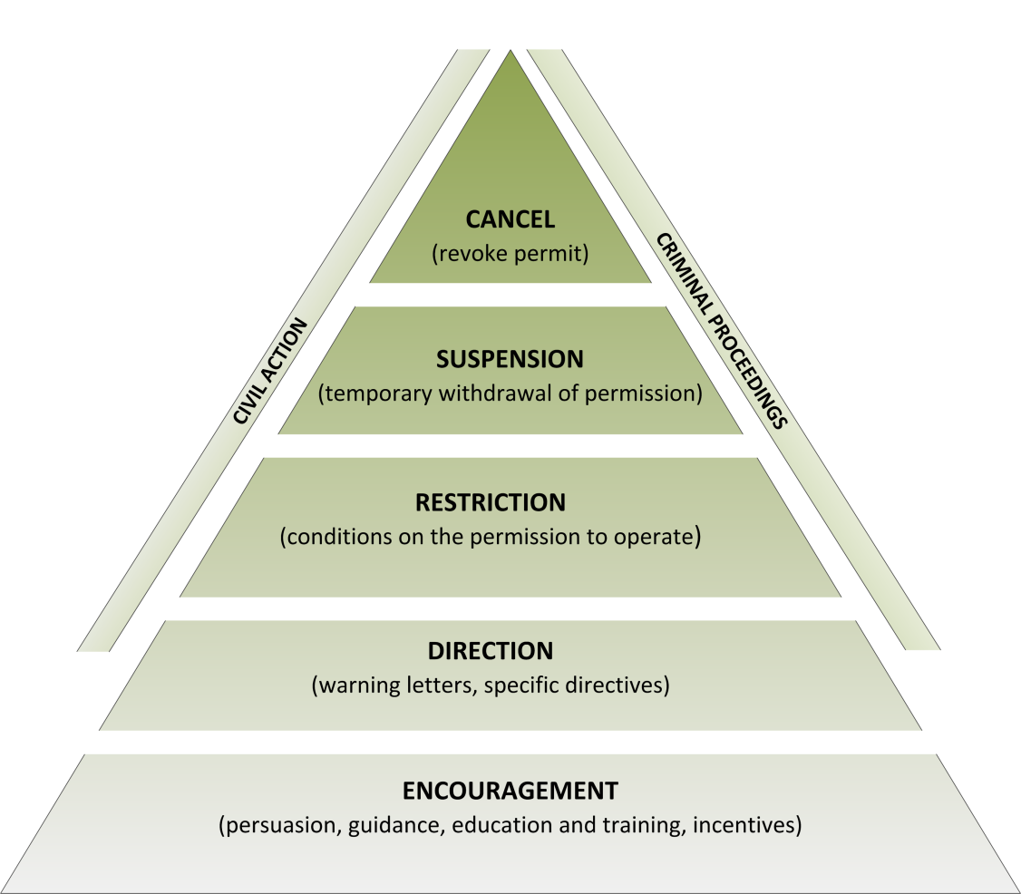
Source: ANAO. Based on the enforcement pyramid in Ian Ayres and John Braithwaite, Responsive Regulation: Transcending the Deregulation Debate, Oxford University Press, 1992, p. 35.

Indicators of good practice
Overarching principles:
- Businesses report that the range of sanctions that apply for noncompliance are proportionate to the risks of noncompliance.
- Businesses report that sanctions are applied fairly and consistently by the regulator.
- The regulator’s enforcement policy is easily available, easy to understand (in plain language) and well signposted.  - The regulator makes businesses aware of the reasons why enforcement action is necessary.  - Enforcement actions are followed up to ensure that businesses know what is expected of them. |  | Effective communication

- The regulator ensures that regulatory staff undertake enforcement actions consistently ‘on the ground’ and that the actions are achieving regulatory objectives.  - The application of enforcement actions is consistent and in accordance with published enforcement guidance. |  | Consistency
- The regulator has, and makes use of, a sufficient suite of regulatory tools in order to proportionately respond to compliance breaches (carrots and sticks).  - Enforcement actions are proportionate to the seriousness or persistence of, and potential commercial gain from, compliance breaches.  - Alternatives to formal sanctions are considered on a risk basis.  - Businesses that are continuously noncompliant are appropriately sanctioned.  - Businesses are given time to comply (other than in urgent cases). |  | Risk-based and proportionate
- The regulator avoids perverse incentives that might influence the choice of enforcement actions.  - Time periods for administrative decisions (such as those relating to infringement processes) and achievement towards them are published.  - Statistics about completed enforcement actions are collected by the regulator and publicly released.  - Appeal avenues (both internal and external) exist for enforcement actions. |  | Accountable and transparent
- The regulator seeks regular feedback from business on its enforcement regime to inform continuous improvement in its enforcement strategies.  - The regulator provides training to regulatory staff in applying the appropriate approach to enforcement |  | Continuous improvement

For more information on the derivation and interpretation of both the principles and indicators of good practice in relation to enforcement activities, see PC 2013, chapter 6 and appendix F, NAO-BRE 2008, phase 2 Guidance 9, and ANAO (2007, chapter 8).

Gathering evidence
In some cases, quantitative metrics will be most useful for assessing regulators against the principles. In other instances evidence relating to individual indicators will be of a qualitative nature, and will require subjective judgements on the part of the audit team.

Cross-checking different data sources
Business feedback, administrative and other data from regulators, process audits, and synthetic analysis can be used to form a view on the performance of each regulator against any given indicator. In general, and in particular where subjective data (such as business feedback) is used, attempts should be made to ‘triangulate’ data, to ensure that the representative range of (reasonable) views are sought.

Business feedback
Given that the primary goal of the audit framework is to establish the extent to which regulators are interacting effectively and efficiently with business, a key source of information will be the opinion of the latter. To ensure views are representative, surveys should use a random sampling approach. However, self-selected views (as from a member survey or focus group) can still be very useful, particularly in identifying practices that have a significant impact only on a small share of businesses. Verification of the extent to which particular views are held should be part of the data collection design.
Business representative groups that are conducting regular member surveys are a potential source of this information. Also, some regulators already seek feedback from business through their own surveys and information collection processes. To the extent that business feedback already exists (and is suitable for use in the audit) it will reduce the additional impost on businesses of conducting audits. In the absence of existing information, auditors will need to seek feedback from businesses directly.
When seeking the views of business the instrument (such as a survey, interview, or focus group) needs to provide clear information on what the regulator has control over in order for the responses to reflect the performance of the regulator (as opposed to the regulation). However, such instruments can also seek useful information on other aspects of a regulation, such as its effectiveness and appropriateness. Given the cost of data collection, and the value of context, the element on compliance costs is ideally incorporated in broader audit activities.
The development of the audit plan should engage business to ensure that they are willing and able to provide the feedback on the good practice intent set out in the plan.

Administrative data
Administrative data collected by regulators is likely to be the source of some metrics necessary for audit. Examples of data that regulators may collect and collate include:
- compliance rates
- statistics on licensing and approvals processes, including time taken
- statistics relating to data quality checks, completion error rates, complaints registers, dispute resolutions etc.
- statistics on the number of breaches and enforcement actions
- staff training statistics (numbers, expenditure, courses)
- regulator operating costs.
The audit plan should set out the administrative data that needs to be collected to ensure that the information can be made available at the time of the audit. Attention must be paid to how the data will be compiled as administrative data that have been collected on paper but are not available electronically is generally of limited use.

Assessments of regulator processes
Auditors will need to examine the key processes that regulators have in place — as documented and as implemented in practice. Websites can be examined for published information on a range of processes, including risk assessment models, enforcement strategies, and code(s) of practice. They can also be examined to assess the quality, clarity and accessibility of advice and guidance, and the extent to which businesses can interact with the regulator online.
Internal guidance and training documents can provide evidence of the extent to which regulatory staff are being appropriately trained in providing advice and guidance to businesses, or in conducting inspections/investigations.
Where recent audits of regulator performance (or some of their main activities or processes), or of the regulation have been undertaken, the results could provide useful information and data for auditors.

Synthetic analysis
Auditors can generate estimates of business compliance costs and make qualitative assessments of other aspects of regulator behaviour and interaction through synthetic analysis. In this approach, the auditor (or a consultant acting on their behalf) acts as a standard business and simulates engagement or interaction with a regulator, such as going through the steps involved in making a licence application or applying for an approval or permit. Data and qualitative information about the experience — such as response turn-around times, or the time taken to acquire information or complete forms — is recorded and summarised.
A limitation of this approach is that the data are not necessarily representative of the ‘real world’ experience of businesses. (For more information, see PC 2008c, p. 208).

Consultations with business, regulators, and policy departments
Apart from the critical role that consultations with stakeholders will play in developing the audit plan specific to each regulator, the auditor should meet with stakeholders towards the end of the audit process to:
- test the evidence on which assessments of performance have been made, and the overall assessment of regulator performance. For example, if assessments have been made using the traffic light signalling approach (green equals excellent, amber equals satisfactory, red equals unsatisfactory), final stakeholder consultations would provide an opportunity to assist the auditor determine the final report against the high level principles across each of the areas of regulator activity
- propose ways in which regulator performance could be improved
- identify any gaps in the assessment process and consider ways to address the problem if they compromise the usefulness of results
- confirm the appropriateness of the indicators used and consider whether they should be retained or improved for future assessments.

Suggested report outline
Figure 2 illustrates a suggested outline for the written report. As noted earlier, depending on how the audit process is implemented, the proposed report may be a stand-alone document, a chapter in the regulator’s annual report, or it may form one component of a broader audit of regulator performance that also examines the administrative efficiency of the regulator, the achievement of regulatory objectives and the design of the regulations. (Implementation issues are canvassed in more detail in chapter 3).
Figure 2 Suggested outline for written assessments of regulator performance
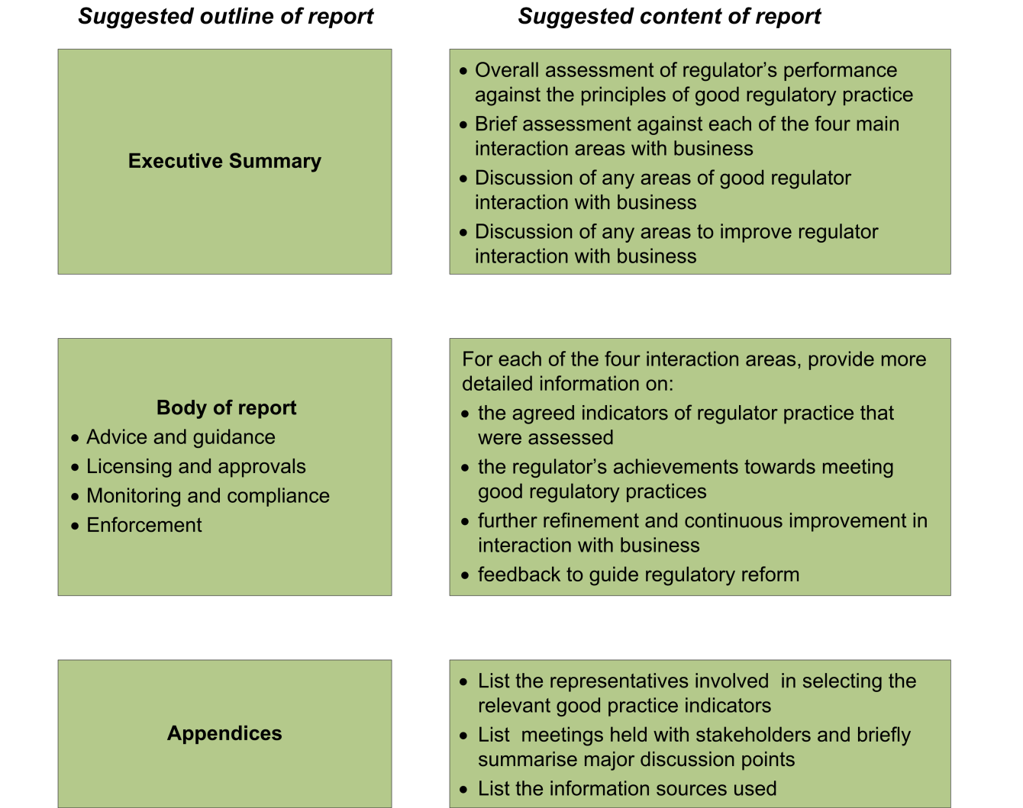

Information sources and other references
On the regulator performance framework, important reference and source documents include:
- National Audit Office (UK) 2007, Hampton Implementation Reviews: Guidance for Review Teams, May.
- National Audit Office (UK) 2008, Effective inspection and enforcement: implementing the Hampton vision in the Environment Agency, http://www.nao.org.uk/wp-content/uploads/2008/03/EA_Hampton_report.pdf (accessed 8 October) March.
- Victorian Competition and Efficiency Commission 2011, Strengthening Foundations for the Next Decade: An Inquiry into Victoria’s regulatory framework, April.
- Victorian Government 2012, Victorian Government response to the Victorian Competition and Efficiency Commission’s Final Report – Strengthening Foundations for the Next Decade: An Inquiry into Victoria’s regulatory framework, March, Department of Treasury and Finance, Melbourne.
- Victorian Department of Treasury and Finance 2013, Guidelines for Preparing Reducing Red Tape Statements of Expectations for Regulators, January, Melbourne.
Examples of regulator reviews conducted in the UK using the Hampton model can also be downloaded from the National Audit Office website (www.nao.org.uk). They include studies of the following regulators: Financial Services Authority; Food Standards Agency; Health and Safety Executive; and Office of Fair Trading.
On the development of the principles of good regulator practice, relevant documents include:
- Australian National Audit Office 2007, Administering Regulation: Better Practice Guide, March.
- National Audit Office-Better Regulation Executive, 2008, Effective Inspection and Enforcement: implementing the Hampton vision in national regulators, Phase 2 Guidance for Review Teams, July
- Office of Best Practice Regulation 2007, Best Practice Regulation Report 2006-07, Annual Report Series, Productivity Commission, Canberra.
- Productivity Commission 2013, Regulator Engagement with Small Business, Research Report, October, Canberra.
- Productivity Commission 2012, Regulatory Impact Analysis: Benchmarking, Research Report, November, Canberra.
- Productivity Commission 2011, Identifying and Evaluating Regulation Reforms, Research Report, Canberra.
- Regulation Taskforce 2006, Rethinking Regulation: Report of the Taskforce on Reducing Regulatory Burdens on Business, report to the Prime Minister and the Treasurer, Canberra.
Beyond these reports, the PC has published a number of studies examining the regulatory burdens on businesses, as well as a number of performance benchmarking studies of business regulation. They are all available as downloads from the PC’s website: www.pc.gov.au.

3 Institutional arrangements for implementing the framework
The audit framework outlined in chapter 2 is designed to be independent of the institutional architecture within which the audits are conducted. However, the architecture is critical to the effectiveness of the audits in improving the performance of regulators.

Current institutional arrangements
The institutional architecture needs to assign responsibility for audit plans to be developed, and for regulators to be audited against these plans on a regular basis. To be effective in providing regulators with an incentive to improve their performance, sanctions and/or rewards are needed for good regulator performance/improvements in performance. The institutional architecture is critical in establishing these sanctions and rewards, that is, in ensuring accountability from regulators for their performance.
The choice of institutional arrangements will in part be determined by the broader accountability and performance reporting mechanisms that are either already in place or are likely to be implemented in the near future. The Public Governance, Performance and Accountability (PGPA) Act 2013 is still in the implementation stage. A requirement under this Act is that Commonwealth entities (which includes Commonwealth regulators) prepare annual performance statements, and that these statements ‘provide information about the entity’s performance in achieving its purposes’. Given this, the regulator audit framework proposed in this paper could be seen as providing the basis for one element or module of the broader reporting requirements regulators face under this Act. For example, the framework could be incorporated into the Act either as a direct amendment to the Act, or it could form part of the (as yet undeveloped) rules relating to performance: s 102(g).

Other institutional developments
In addition to their election commitment to audit the performance of government regulators, the current Government committed to a number of other initiatives relevant to the issue of regulatory burden on business. These include:
- the issuing of Ministerial statements of expectation (SOEs) to the heads of Commonwealth regulatory agencies.
- the establishment of deregulation units within each department and agency
- requirements that each department and agency audit and quantify the cost to businesses and individuals of complying with regulation
- the establishment of Ministerial Advisory Councils, consisting of industry stakeholders, for each Cabinet Minister
These developments also have implications for the implementation of the proposed regulator audit framework, particularly the issuing of Ministerial SOEs. For example, ensuring some degree of consistency between SOEs for regulators and the principles of good practice used in the proposed regulator audit framework (effective communication, a risk-based approach to inspections, proportionate responses to compliance breaches etc.) could achieve greater commitment to the overall process, and enhance the prospects of achieving genuine improvements in regulator performance.
The Government is in the process of developing a whole-of-government risk management framework. The critical element of any risk management framework is the recognition of the cost of managing risk relative to the benefits achieved. These benefits depend on the probability and cost associated with the risk and on the effectiveness of the efforts to reduce risk or to mitigate the costs should the risk eventuate. This audit framework, as it focuses on minimising the cost to businesses while achieving the objectives of the regulation, should support the adoption of a risk-based approach to enforcement and compliance by Commonwealth regulators that will form part of this broader risk management framework.
Across many developed countries, there has been a tendency towards increasingly strong regulatory interventions to reduce risk to the public. In part this is because the demand for many of the things that regulation addresses, such as safety and the natural environment, tends to rise with income. But it is also due to false perceptions of risk, and a lack of understanding that many risks cannot be easily removed, and that attempts to reduce one risk can easily result in risk transfer rather than risk reduction (see for example, Bayer 1993, Graham and Weiner 1997).
As set out by the OECD (2010) a comprehensive approach to risk management would include:
… comprehensive regulatory impact assessment of the full portfolio of impacts of risk reduction efforts; both ex ante (prospective) regulatory impact assessment to inform initial policy decisions, and ex post (retrospective) regulatory impact assessment to inform subsequent policy revisions and to improve ex ante assessment methodologies; even-handed use of regulatory analysis both to discourage undesirable policy proposals and to encourage desirable policy proposals; greater use of economic incentive instruments in regulation; and better coordination and oversight of risk regulation policies across agencies within each government, and across governments internationally. (p. 12).
As summarised in table 1, Australian governments have a number of these elements in place already. However, Commission studies have found that not all regulatory impact assessments function as well as they should (PC 2012), and that gaps remain in ex post assessment of the need for and performance of regulations (PC 2011). Moreover, while Australia has been a leader in introducing risk-based approaches to regulation with many regulators adopting these approaches, there is still considerable scope for further improvement (box 2).
Rigorous application of the framework set out in this paper should work to reduce unnecessary compliance costs. But more fundamental efforts will be required to ensure that regulation is only implemented and continued where the economic and social benefits exceed the costs, and that where this is the case the most cost effective approaches are applied. This will require a more informed conversation with the Australian public about what governments can do to manage risk and what it will cost, not just for government but to businesses and other regulated entities, and the public more generally. The costs are not only financial, but include ‘social’ costs such as curtailing individual freedoms and eroding personal responsibilities.

Box 2 Past Commission suggestions for strengthening the whole of government risk management framework for regulation
The main elements of Australian government processes to ensure that regulation addresses real problems, is cost-effective, and pass a cost-benefit test and the need for improvements in each are as follows:
- Developing new regulation: regulation that imposes a non-minor (check wording) cost on businesses, not-for-profit organisations or the community requires passing a cost-benefit test (is appropriate). The analysis, which includes consideration of regulatory options, is documented in a Regulation Impact Statement (RIS). Commission studies have found that RISs are often done after the decision on a regulation has been made, rather than being used to determine the appropriateness and effectiveness of the proposed regulation. Moreover exemptions have been granted for major pieces of legislation, some on the grounds that they are election commitments and so have been tested by the ballot box, which is a very blunt test. Such legislation is mean to be subject to a Post-Implementation Review, but the scope of such reviews does not appear to address appropriateness.
- Administering a regulation: regulators are already subject to audits of their administrative efficiency, and regulatory effectiveness. The willingness of government to act on the recommendations of these audits determines their effectiveness in improving the performance of the regulator. A gap is the impact of the regulation on the costs imposed on regulated entities by how the regulation is administered. The framework developed in this paper is designed to fill this gap.
- Reviewing the stock of regulation: Some regulation and quasi-regulation is subject to sunset provisions (in their legislation of the generis sunset provision that applies to quasi-regulation). Sunset provisions require that regulation be reviewed and rolled over or repealed. The Australian Government Legislative Instruments Act 2003 provided for a staged introduction which should see 2014 have to review, remake or repeal a considerable volume of regulation. In 2012 the Commission recommended that departments utilise the opportunity to review primary legislation when sub-ordinate legislation was due to sunset, as a means of reviewing the stock of regulation. While the Legislative Instruments Amendment Bill of 2012 provided for better management of sunsetting regulation by allowing bundling of related regulation for review, it does not require primary legislation to be revisited. This process is in addition to ad hoc reviews (such as Productivity Commission Inquiries) that are a response to current issues that warrant special attention. This systematic approach was seen as preferable to regulatory budgets and red tape targets, which can result in unintended consequences such as delaying repeal and streamlining to bank roll against a need for future regulation, and to avoid repealing necessary regulation.
Sources: PC 2011, 2012.

Options for implementing the framework
Beyond the broader institutional architecture, the implementation of the framework requires consideration of the following:
- Who conducts the audits?
- How the quality of individual audits is assured?
- How the audits are used to improve regulator performance and the reduce the burdens of regulation more generally?
In addition, portfolio Ministers of Departments need to have arrangements in place to assess regulator’s compliance with relevant Government policies, such as obligations in statements of expectations, and completing RISs where regulators are developing and implementing regulations in their own right.

Who should conduct the audits?

Departmental audits
One option would be for the relevant departments to take primary responsibility for working with the regulator and other stakeholders to develop the audit plan and then later conduct the audit. These activities might be undertaken by staff in the newly created deregulation divisions within each department.
A positive of this approach is that it has the potential to minimise costs by leveraging the statement of expectations and statement of intent process, and the establishment of deregulation units and Ministerial Advisory Councils. It should also promote the integration of this audit with audits of other elements of regulator performance and reviews of the regulation. On the other hand, there is the potential for reduced impartiality and objectiveness (which is particularly important for reviews of the regulation), as well as varying degrees of rigour and application across departments.

Regulator self-assessments
Regulator self-assessment against an agreed audit plan is likely to be feasible in some cases. However, some smaller regulators may require assistance to undertake this task.
As with the first model, a limitation of this approach is that there may be reduced impartiality and objectiveness, notwithstanding the fact that all vested interests should have been consulted on the indicators and metrics used to assess performance and the reports subject to their scrutiny. An external audit process to randomly check the reliability of the self-assessment would reduce the incentives for bias in self-assessment, as can the publication of the report.

Specialist audit agency assessments
A single body or agency, including one specifically established for the task, could be tasked with undertaking the development of audit plans (in cooperation with each regulator) and their subsequent assessment. This body (the Coalition Policy document suggested the OBPR, but ANAO may also be well placed) could be asked to consider taking on responsibility for organising each audit and preparing the written reports. Such a model might share characteristics with other third party style reviews, such as Productivity Commission inquiries, and is similar to the model adopted in the UK for reviews of the implementation of the Hampton principles for regulator behaviour.
An advantage of this approach is that audits are conducted by specialist staff in a dedicated body, and this may enable a more objective and rigorous approach to the audit process. It would also assist in enhancing consistency across audits (albeit, subject to appropriate tailoring), enabling better benchmarking and cross regulator comparisons.
A disadvantage of this approach is that it is likely to require substantial new resources. (The Hampton reviews in the UK, for instance, used four-person review teams with additional staff providing back-room assistance, with each review taking a number of months to complete.) Also, it may be somewhat duplicative of other audit processes, notwithstanding that the auditors should draw on existing reporting as far as possible.
An alternative is for such a body to provide oversight to the planning and audit processes. They could offer expert input in the planning stage, advice for auditors, and conduct random or programmed external audits to assess the quality of self-audits. Departmental or regulator assessments could be conducted annually with less frequent specialist/independent audits, unless the regulator is getting negative assessments. It may also be possible for these less frequent audits to be integrated into other processes such as ANAO performance audits (which focus on administrative efficiency and effectiveness).
Where businesses are regulated by a number of agencies with interrelated requirements, coordination of external audits should be considered to reduce the burden imposes on business.
Frequency of audits
The frequency of audits should be determined by the potential gain offered by the audit process. All regulators should be required to prepare audit plans based on the framework. The frequency of the audit, particularly external audits, should be determined on a case by case basis. While annual public self-reporting would be appropriate for large regulators that produce annual reports, this may be more frequent than required for smaller regulators which do not have a large or diverse client base. However, all regulators should be encouraged to self-report on an annual basis against at least some of the indicators in their audit plan. These should be identified in the plan as those that will best reflect the improvements that matter most for the regulated entities. Such annual reporting should not remove the need for a full report against the audit plan at an agreed time.
The need for external verification of self-reports (and departmental reports) or external audits will also vary across regulators. Given the resources involved in external audit, departments are likely to be able to fund an external audit for only a few regulators a year. They should prioritise those that impose the greatest compliance costs on business, and/or those where business concerns about regulator behaviour are greatest. Good audits that are external or externally verified should win an agency a lower audit frequency, but ultimately all regulators should be externally audited within a five year period. As mentioned, ideally this audit will be included in a broader audit of regulator objectives and outcomes, and departments should plan accordingly.

How is the quality of individual audits assured?
There are several ways to provide quality assurance of the audit plans and the audit reports. The first is formal oversight processes. The second is to use public scrutiny.
Oversight can be conducted at several levels. One level is to ensure that good processes have been followed. This would involve checking that audit plans have been developed, and that audits are undertaken and reported as agreed. A requirement for audit plans and reports to be posted in a central location, with follow-up if they are not, could be adequate to achieve this level of oversight.
A more involved level would be for the oversight agency to participate as an adviser in the development of audit plans and conduct of audits. They could also check the final audit report and make an assessment of the adequacy of the audit. In many ways this role would be akin to the one the OBPR plays in ensuring the quality of departmental ‘Regulation Impact Statements’.
Random external audits can also be used to assess the competency of the audit. This form of oversight could be achieved by including this ‘compliance cost’ module in audits undertaken to assess the achievement of regulatory objectives or other more comprehensive audits.
A complement to formal oversight responsibilities is exposure to public scrutiny. By publishing the audit plans and audit reports and providing an opportunity for public comment, such scrutiny can provide incentives for honest self-assessment. This form of quality assurance requires activist stakeholders, and can be subject to abuse by disgruntled people. However, if major costs are being imposed that could be reduced by better performance, businesses should have an incentive to monitor the audit plans and reports and to report when they perceive that the plans are inadequate or the audit falls short of an accurate reflection of regulator behaviour.
If responsibility for the audits falls to an independent specialist audit agency or body, quality control is less likely to require external oversight, although it will be important that their audit processes are transparent and inclusive. Public notification of the audits, opportunities to provide input from a full range of stakeholders, and release of a draft for public comment are key elements to an independent audit process.
Regardless of the approach taken to quality assurance, both audit plans and audit reports should be published in a central location for easy access by businesses and other stakeholders with an interest in the outcomes. This responsibility could sit with the OBPR, and would complement their role as the central source for RISs and their associated documents. Public transparency of this nature improves the ability of business and other stakeholders to provide feedback or manage their affairs to be able to engage most efficiently in consultation. It also provides an incentive for regulators to improve their performance.

How can the audits improve regulator performance?
The audits can enhance regulator performance through improving their incentives to perform well, and through identifying ways in which they can do so. Regulator culture is a critical input into performance. Consequently, for the audit framework to add the most value it should be targeted at creating a culture that promotes clear and effective communication, ensures consistency in all its actions, embraces a risk-based approach, practices good governance (accountable and transparent), and values continuous improvement.
The incentives to follow these good practice principles will be strengthened by institutional arrangements that set up formal obligations for regulators to account for and publicly report on their performance. A Ministerial letter of expectations and regulator statement of intent, with rewards and sanctions, can be one such mechanism. To the extent that audits identify ‘room for improvement’ in individual regulators it will be important that some mechanism exists that helps the regulator determine how to improve. The use of diagnostic indicators can assist in pointing to the required area for improvement. Regulators may be able to develop their own improvement strategies, but some may require assistance. This may be in the nature of advice, but may also require investments in new technology and/or staff training. As in all such situations, the benefits of change will need to exceed the costs of making the change.
There can also be an opportunity for the audits to add to the knowledge base of what works well. To the extent that audits highlight regulator strategies and practices that are particularly successful in avoiding unnecessary burden on businesses and achieving regulatory objectives most efficiently, having a mechanism to encourage wider adoption of these practices would assist to improve the overall performance of regulators.
Benchmarking against other regulators can also provide an incentive for regulators to improve their performance. It also allows for the overall achievements and improvements in the performance of regulators across portfolios and overall to be assessed. The framework sets out five main principles and four areas of regulator activity that form a summary matrix for each regulator that could be used to compare how different regulators are performing. This could be done using a traffic light type system to indicate excellent (green), satisfactory (amber), and unsatisfactory (red) performance in each part of the matrix. Such an analysis would allow for easy identification of areas with common underperformance, where a more systemic approach to improving regulator performance may be warranted.
The Department of Prime Minister and Cabinet, which has oversight of the Government’s deregulation agenda, could draw on the regulator audits to report on progress in reducing compliance costs to business. They are also best placed to oversee action on regulations themselves in response to feedback received in the audit reports. In some cases this may be directing departments to review regulations, in others it could be providing advice to regulators on the scope they have to redesign the regulatory approach to improve the efficiency and effectiveness of the regulation. Independent regulators may need amendments to their governing legislation and/or charters if these constrain their ability to take a risk-based and efficient approach to achieving the objectives of the regulation they administer.

References
Australian National Audit Office 2007, Administering Regulation: Better Practice Guide, March.
Australian National Audit Office 2013, The Australian Government Performance Measurement and Reporting Framework: Pilot Project to Audit Key Performance Indicators, ANAO Report No. 28 2012-13
Breyer, S., 1993, Breaking the Vicious Circle: Toward Effective Risk Regulation, The Oliver Wendell Holmes Lectures 1992, President and Fellow of Harvard College, Boston.
Graham, J.D. and Weiner, J.B. (eds), 1997, Risk vs Risk: Trade-offs in Protecting health and the Environment,
Liberal Party of Australia, 2013, The Coalition’s Policy to Boost Productivity and Reduce Regulation, July. (http://www.liberal.org.au/our-policies accessed on 31 October 2013)
Matthews, M. and White, G. 2013, Faster and smarter: using a hypothesis-testing approach to policy and program evaluation, Technical Memorandum Prepared for the OECD Expert Group on the Evaluation of Industrial Policy, August.
PC (Productivity Commission) 2008, Performance Benchmarking of Australian Business, Regulation: cost of business registrations, Canberra
—— 2011, Identifying and Evaluating Regulation Reform,, Research Report, December, Canberra.
—— 2012, Regulatory Impact Analysis: Benchmarking, Research Report, November, Canberra.
—— 2013, Regulator Engagement with Small Business, Research Report, October, Canberra.
OECD, 2010, Risk and Regulatory Policy: Improving the Governance of Risk, OECD, Paris.
Office of Better Practice Regulation (OBPR), 2010, Best Practice Regulation Handbook, Canberra.
Sparrow, M.K. 2013, Operational risk management as regulatory strategy, presentation to ANZSOG, 8 May 2013, http://www.anzsog.edu.au/magma/media
/upload/ckeditor/files/Alumni%20Events/EFP%20Refresher%202013%20Malcolm%20Sparrow%20What%20is%20a%20Risk%20Based%20Regulator.pdf
Sparrow, M.K., 2011, The Regulatory Craft: Controlling Risks, Solving Problems, and Managing Compliance, Brookings Institution Press, Washington DC.

Other regulated entities includes not-for-profit organisations, and individuals to the extent that they are the directly regulated entity (such as with tax returns).
The on-going need for regulation is often not adequately challenged in many audit processes, in part as this requires a comprehensive ex post evaluation of the primary legislation (PC 2012).
To the extent that regulators set fees based on cost recovery, their administrative efficiency also has impacts on business. As administrative efficiency is audited by ANAO and overseen by the policy departments, it is outside the scope of the audit framework set out in this paper.

